IEEE P802.11
Wireless LANs
Spatial Mapping for HE Ranging
Date: 2024-4-15
Author(s):
Name | Affiliation | Address | Phone | email
Youhan Kim | Qualcomm Technologies, Inc. |  |  | youhank@qti.qualcomm.com

Abstract
This submission proposes resolutions for the following CIDs from SB2 on REVme D5.0:

7016, 7017, 7018, 7020

NOTE – Set the Track Changes Viewing Option in the MS Word to “All Markup” to clearly see the proposed text edits.

Revision History:

R0: Initial version.

CID 7016, 7017

CID  Clause  Page.Line | Comment | Proposed Change
7016  27.3.19.1  4387.1 | Firstly, since how to assign indices to antenna chains is implementation dependent, the Q matrix doesn't have to be an Identity matrix. Requiring the Q matrix to be a binary unitary matrix of size N_TX x N_TX (elements restricted to 0 or 1) should be sufficient.  Secondly, the sentence "the Q matrix shall be based on an antenna selection matrix with no antenna swapping" is not clear. Both "antenna selection matrix" and "antenna swapping" are not defined anywhere in the spec draft. | Change the paragraph to "For transmission of HE-STFs and HE-LTFs, if NSTS = N_TX, the Q matrix shall be a binary unitary matrix of size N_TX x N_TX, and if NSTS < NTx, the Q matrix shall become a binary unitary matrix of size NSTS x NSTS after rows with all 0s are removed. The Q matrix shall not be changed during HE Ranging NDP transmissions." Define "binary unitary matrix" in Clause 3.1 as "unitary matrix with the values of elements restricted to 0 or 1."
7017  27.3.19.2  4389.39 | Firstly, since how to assign indices to antenna chains is implementation dependent, the Q matrix doesn't have to be an Identity matrix. Requiring the Q matrix to be a binary unitary matrix of size N_TX x N_TX should be sufficient.  Secondly, the sentence "the Q matrix shall be based on an antenna selection matrix with no antenna swapping" is not clear. Both "antenna selection matrix" and "antenna swapping" are not defined anywhere in the spec draft. | Change the paragraph to "For transmission of HE-STFs and HE-LTFs, if NSTS = N_TX, the Q matrix shall be a binary unitary matrix of size N_TX x N_TX , and if NSTS < NTx, the Q matrix shall become a binary unitary matrix of size NSTS x NSTS after rows with all 0s are removed. The Q matrix shall not be changed during HE TB Ranging NDP transmissions."

Discussion
REVme D5.0 P4387:
REVme D5.0 P4389:

How the antennas are ‘numbered’ on products is outside the scope of the IEEE 802.11 standard. Hence, even if the IEEE 802.11 standard uses an identity matrix as the spatial mapping matrix, product manufacturers can map the rows of the spatial mapping output to different physical antennas as they deem necessary. Therefore, it is sufficient for the IEEE 802.11 standard to use an identity matrix as the spatial mapping matrix without restricting products on which specific antennas are connected to each row of the spatial mapping output. See REVme D5.0 P2145L19, P3503L25 and P3503L1 for example of using the identity matrix as the spatial mapping matrix.
The commenter also suggested to allow a “binary unitary matrix of size N_TX x N_TX (elements restricted to 0 or 1)” in place of the identity matrix. The reason for requiring the use of an identity matrix in the HE ranging is to have each spatial stream be transmitted on only transmit antenna, and one transmit antenna transmitting at most one spatial stream. This is because CSD is often used if a transmitter transmits multiple spatial streams over a given transmit antenna, in which case the ranging measurement gets confused by the CSD (having hard time distinguishing real channel delay vs. CSD). A “binary unitary matrix of size N_TX x N_TX (elements restricted to 0 or 1)” allows multiple spatial streams to be transmitted over a given transmit antenna, hence should not be allowed for HE ranging.
Commenter is correct that "antenna selection matrix" and "antenna swapping" are not defined terms. Proposed text changes in this document avoids using these undefined terms.

Proposed Resolution: CID 7016
REVISED

Instruction to TGme Editor:
Implement the proposed text updates for CID 7016 in https://mentor.ieee.org/802.11/dcn/24/11-24-0698-00-000m-spatial-mapping-for-he-ranging.docx

Note to Commenter:
HE ranging requires each transmit antenna to carry at most one spatial stream. The “binary unitary matrix (elements restricted to 0 or 1)” proposed by the commenter breaks this requirement, hence is not appropriate for HE ranging.
The proposed text change above avoids using the undefined terms "antenna selection matrix" and "antenna swapping".

Proposed Resolution: CID 7017
REVISED

Instruction to TGme Editor:
Implement the proposed text updates for CID 7017 in https://mentor.ieee.org/802.11/dcn/24/11-24-0698-00-000m-spatial-mapping-for-he-ranging.docx

Note to Commenter:
HE ranging requires each transmit antenna to carry at most one spatial stream. The “binary unitary matrix (elements restricted to 0 or 1)” proposed by the commenter breaks this requirement, hence is not appropriate for HE ranging.
The proposed text change above avoids using the undefined terms "antenna selection matrix" and "antenna swapping".

Proposed Text Update: CID 7016

27.3.19.1 HE Ranging NDP
…
Instruction to TGme Editor: Update REVme D5.0 P4387L1 as shown below.

- For the HE-STF and HE-LTF fields: If N_{STS} = N_{TX}, the spatial mapping matrix Q shall be an identity matrix. If N_{STS} < N_{TX}, the matrix Q matrix has N_{TX} rows and N_{STS} columns, where the first N_{STS} rows shall be an identity matrix and the remaining rows shall be a zero matrix.

Proposed Text Update: CID 7017

27.3.19.1 HE Ranging NDP
…
Instruction to TGme Editor: Update REVme D5.0 P4389L39 as shown below.

- For the HE-STF and HE-LTF fields: If N_{STS} = N_{TX}, the spatial mapping matrix Q shall be an identity matrix. If N_{STS} < N_{TX}, the matrix Q matrix has N_{TX} rows and N_{STS} columns, where the first N_{STS} rows shall be an identity matrix and the remaining rows shall be a zero matrix.

CID 7018

CID  Clause  Page.Line | Comment | Proposed Change
7018  27.3.20.1  4390.34 | Since identity matrix is always square, there is no need to include "square". Also, if the purpose is to avoid beamforming, Q matrix just needs to be a binary unitary matrix. | Change the sentence to "No beamforming is applied; Q is a binary unitary matrix"

Background
REVme D5.0 P4390:
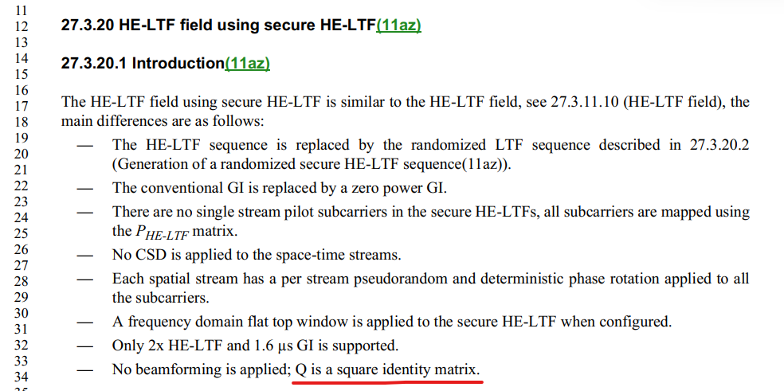

Proposed Resolution: CID 7018
REVISED

Instruction to TGme Editor:
Implement the proposed text updates for CID 7018 in https://mentor.ieee.org/802.11/dcn/24/11-24-0698-00-000m-spatial-mapping-for-he-ranging.docx

Note to Commenter:
Agree with the commenter that an identity matrix is always square, hence the word ‘square’ is redundant. Note that HE ranging requires only one spatial stream to be transmitted over a given transmit antenna, hence changing the spatial mapping matrix Q to be any arbitrary unitary matrix is not appropriate.

Proposed Text Update: CID 7018

27.3.20.1 Introduction
…
Instruction to TGme Editor: Update REVme D5.0 P4390L34 as shown below.

- No beamforming is applied; If N_{STS} = N_{TX}, the spatial mapping matrix Q is an identity matrix. If N_{STS} < N_{TX}, the matrix Q matrix has N_{TX} rows and N_{STS} columns, where the first N_{STS} rows constitute an identity matrix and the remaining rows constitute a zero matrix.

CID 7020

CID  Clause  Page.Line | Comment | Proposed Change
7020  27.3.20.6  4401.40 | No need to include "block" in the sentence. Making Q matrix to be a binary unitary matrix is sufficient. | Change the sentence to "There is no spatial mapping. The Q matrix shall be a binary unitary matrix"

Background
REVme D5.0 P4401:
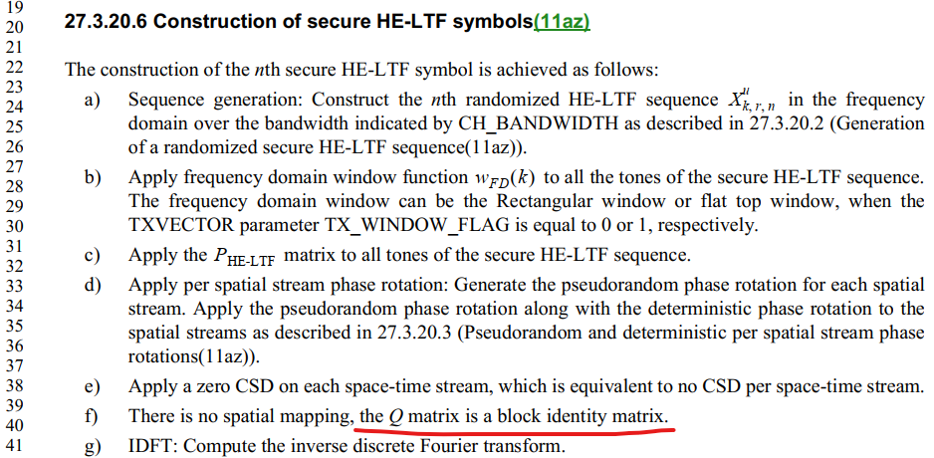

Proposed Resolution: CID 7020
REVISED

Instruction to TGme Editor:
Implement the proposed text updates for CID 7020 in https://mentor.ieee.org/802.11/dcn/24/11-24-0698-00-000m-spatial-mapping-for-he-ranging.docx

Note to Commenter:
“Block identity matrix” is not a defined term, hence
Agree with the commenter that an identity matrix is always square, hence the word ‘square’ is redundant. Note that HE ranging requires only one spatial stream to be transmitted over a given transmit antenna, hence changing the spatial mapping matrix Q to be any arbitrary unitary matrix is not appropriate.

Proposed Text Update: CID 7020

27.3.20.6 Construction of secure HE-LTF symbols…
Instruction to TGme Editor: Update REVme D5.0 P4401L40 as shown below.

- There is no spatial mapping. If N_{STS} = N_{TX}, the spatial mapping matrix Q is an identity matrix. If N_{STS} < N_{TX}, the matrix Q matrix has N_{TX} rows and N_{STS} columns, where the first N_{STS} rows constitute an identity matrix and the remaining rows constitute a zero matrix.

[End of File]

