IEEE P802.11
Wireless LANs
Proposed Resolution for CID 7079 and more
Date: 2024-04-15
Author:
Name | Affiliation | Address | Phone | Email
Emily Qi | Intel Corporation | 2111 NE 25th Ave.  Hillsboro OR 97124 |  | Emily.h.qi@intel.com

This submission present proposed resolutions for 11az/11bd/11bb Roll-in related CIDs.

The proposed changes are based on REVme/D5.0.

Revision history:

R0 – initial version

7079 | 3077.00 | 12.7.1.3 | 11az work item - 11az instructs TGme editor to replace Figure 12-29. However this figure has been modified by two CIDs. Changes need to be identified instead of replacement. | as in comment. |  | SEC

Discussion:

In the published 11az standard, it states:
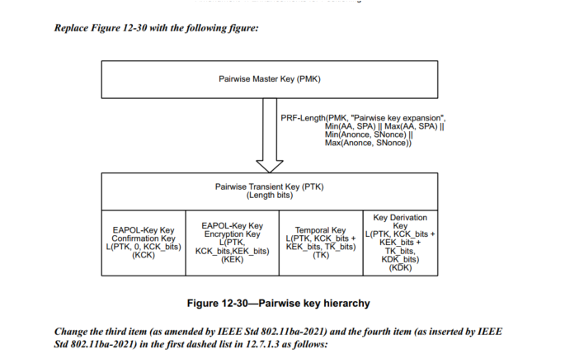

The above figure is identical with the figure in 11ba standard:
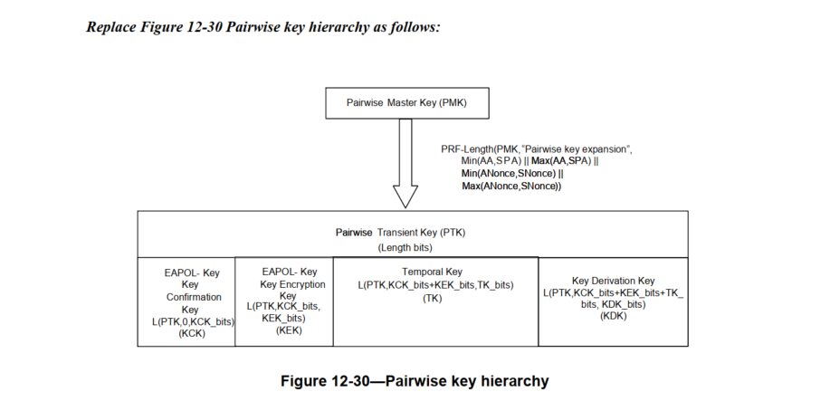
Since 11ax is based on 11ba, the editing instruction in 11az was wrong.

The more important, after 11ba roll-in, this figure has been modified by CID 3744 and CID #4057. Now, this figure in D 5.0 is shown as below:

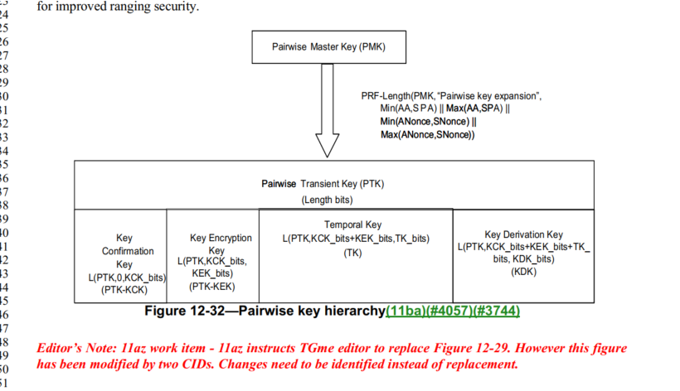

CID 3744: removed EAPOL-Key
CID 4057: Replace "(KCK)" with "(PTK-KCK)" and "(KEK)" with "(PTK-KEK)".

Therefore, TGme editor should not do any change or replacement for Figure 12-32, for 11az roll-in.

Proposed Resolutions:
Revised.
Remove the Editor Note at line 48 to 50 on page 3077.
No change to Figure 12-32 is needed.

7078 | 3068.00 | 12.6.17 | 11az work item - Changes in 12.6.19 of 11az cannot be incorporated in this section. Please review. | as in comment. |  | SEC

Discussion:
In 11az standard, 12.6.19, it states:

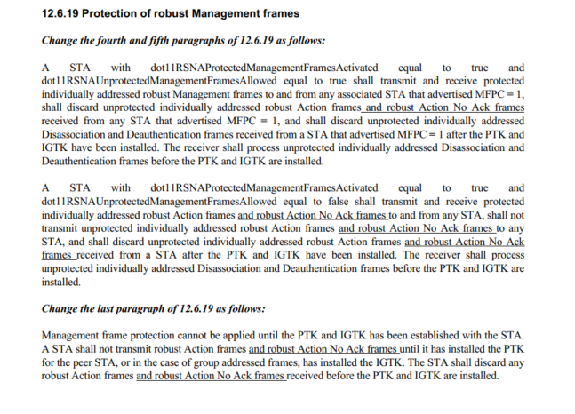
However, I couldn’t find any relevant texts in D4.0.
Subclause 2.6.17 Protection of Robust Management frames (D 4.0) has been changed due to CID 2128 (Doc 21/1128r6, Mark R’s submission).

Help is needed.

Proposed Resolution:

