IEEE P802.11
Wireless LANs
Resolution to MLO MBSSID CIDs
Date: 2024-03-12
Author(s):
Name | Affiliation | Address | Phone | email
Michael Montemurro | Huawei |  |  | montemurro.michael@gmail.com
Background
This contribution addresses CIDs 22098, 22191, 22231, 22339 to align the P802.11be draft.

Comment
CID | Clause | Page | Comment | Proposed Change
22098 | 35.3.20 | 583.57 | The implied requirement here goes beyond the behavior describe in the baseline and affects deployment scenarios where the same SSID could be used to advertise multiple BSSs (both transmitted and non-transmitted) in the MBSSID set. | Replace "Each AP, in a multiple BSSID set or a co-hosted BSSID set, is a member of a different ESS while all APs affiliated with the same AP MLD belong to the same ESS (see 35.3.1 (General) and AA.3 (Example illustrating the relationship between MLO and multiple BSSID set or co-hosted BSSID set)). Therefore, an AP MLD shall not have more than one affiliated AP amongst APs that are members of the same multiple BSSID set or of the same co-hosted BSSID set. with "When a multiple BSSID set or co-hosted BSSID set is used with MLO, an AP MLD shall not have more than one affiliated AP amongst APs that are members of the same multiple BSSID set or of the same co-hosted BSSID set.
22191 | 35.3.20 | 582.57 | Unnecessary commas | Remove commas to produce "Each AP in a multiple BSSID set or a co-hosted BSSID set is a member of a different ESS while all APs…"
22231 | 35.3.20 | 582.58 | "Each AP, in a multiple BSSID set or a co-hosted BSSID set, is a member of a different ESS" feels strange. What is that claimed based on? IEEE Std 802.11-2020 (and the current REVme draft for that matter) does not seem to place any such requirement for the multiple BSSID set. Where does this come from? It would be unfortunate if MLO is adding such a new constraint on how MBSSID can be used since there are potential uses for MBSSID for addressing interoperability issues that make it difficult to deployed EHT/MLO in some cases. At minimum, this claim would need a reference to where it is coming from, but it would be better to remove that. The following sentence ("Therefore, ..") depends on this, but it would seem fine to remove the dependency. | Replace "Each AP, in a multiple BSSID set or a co-hosted BSSID set, is a member of a different ESS while all APs affiliated with the same AP MLD belong to the same ESS (see 35.3.1 (General) and AA.3 (Example illustrating the relationship between MLO and multiple BSSID set or co-hosted BSSID set)). Therefore, an AP MLD shall not have more than one affiliated AP amongst APs that are members of the same multiple BSSID set or of the same co-hosted BSSID set." with "An AP MLD shall not have more than one affiliated AP amongst APs that are members of the same multiple BSSID set or of the same co-hosted BSSID set."
22339 | 35.3.20 | 584.58 | [Thomas Derham] Is there a technical necessity for the restriction that two BSSs in an MBSSID (or co-hosted) set cannot be members of the same ESS? Note this somewhat implies that the BSSs cannot have the same SSID (although that is less clear, given SSID alone is not a unique identifier of an ESS). There may be use cases where it is useful to deploy two BSSs in the same set with same SSID but different configurations. | Remove the restriction unless there is a strong technical need for it. (Also related examples in the Annex may need updating)

Discussion:
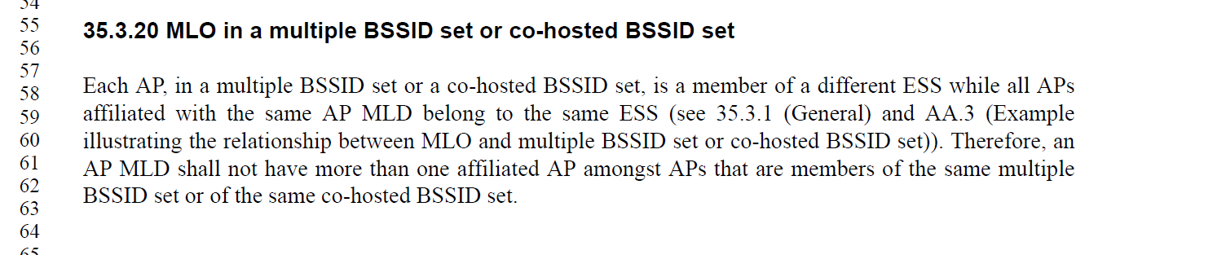
In the baseline for MBSSID, there is no restriction that all BSSs in a MBSSID set belong to a different ESS and there is no reason to add this restriction as part of MLO. The implied requirement here goes beyond the behavior described in the baseline and affects deployment scenarios where the same SSID could be used to advertise multiple BSSs (both transmitted and non-transmitted) in the MBSSID set.
The proposed change is:
Replace
"Each AP, in a multiple BSSID set or a co-hosted BSSID set, is a member of a different ESS while all APs affiliated with the same AP MLD belong to the same ESS (see 35.3.1 (General) and AA.3 (Example illustrating the relationship between MLO and multiple BSSID set or co-hosted BSSID set)). Therefore, an AP MLD shall not have more than one affiliated AP amongst APs that are members of the same multiple BSSID set or of the same co-hosted BSSID set."
with
"An AP MLD shall not have more than one affiliated AP amongst APs that are members of the same multiple BSSID set or of the same co-hosted BSSID set."

Proposed Change:
(22098, 22231, 22191) ACCEPTED

(22339) REVISED. Replace "Each AP, in a multiple BSSID set or a co-hosted BSSID set, is a member of a different ESS while all APs affiliated with the same AP MLD belong to the same ESS (see 35.3.1 (General) and AA.3 (Example illustrating the relationship between MLO and multiple BSSID set or co-hosted BSSID set)). Therefore, an AP MLD shall not have more than one affiliated AP amongst APs that are members of the same multiple BSSID set or of the same co-hosted BSSID set. with "When a multiple BSSID set or co-hosted BSSID set is used with MLO, an AP MLD shall not have more than one affiliated AP amongst APs that are members of the same multiple BSSID set or of the same co-hosted BSSID set.”

