IEEE P802.11
Wireless LANs
LB281 Comment Resolution CSI Feedback
Date: 2024-03-12
Author(s):
Name | Affiliation | Address | Phone | email
Christian Berger | NXP | 350 Holger Way, San Jose, CA |  | christian.berger@nxp.com
Ali Raissinia | Qualcomm |  |  | alirezar@qti.qualcomm.com

Abstract
This submission proposes to address the following CIDs 4058, 4061, 4064, 4100, 4189, 4192, 4246, and 4190 (8 CIDs total), changes are relative to Draft P802.11be_D4.0, Draft P802.11REVme_D4.2, and Draft P802.11bf D3.0.

Revisions:
- Add document link in resolution boxes and edits based on feedback to add clause 11 text for 20 MHz bandwidth.
- Add 11be 20 MHz-only example for discussion

Interpretation of a Motion to Adopt

A motion to approve this submission means that the editing instructions and any changed or added material are actioned in the TGax Draft. This introduction is not part of the adopted material.

Editing instructions formatted like this are intended to be copied into the TGbk Draft (i.e. they are instructions to the 802.11 editor on how to merge the text with the baseline documents).

TGbk Editor: Editing instructions preceded by “TGbk Editor” are instructions to the TGbk editor to modify existing material in the TGaz draft. As a result of adopting the changes, the TGbk editor will execute the instructions rather than copy them to the TGbk Draft.

The text preceded by “Discussion” is not part of the adopted changes.

CID | P.L | Clause | Comment | Proposed Change | Resolution
4058 | 76.22 | 9.4.2.321 | My previous CID3086 was rejected with a reason "lack of consensus" as shown in doc 23-2093r2. This is not a valid reason to reject a technical comment | Refer to CID 3086. | Revised  TGbf editor, make the changes identified in document  https://mentor.ieee.org/802.11/dcn/24/11-24-0582-02-00bf-lb281-comment-resolution-csi-feedback.docx
4061 | 76.22 | 9.4.2.321 | My CID 3139 to LB276 was rejected with the reason "The TG could not reach consensus on the changes necessary to address the comments ...". This is not a valid reason for rejection to a technical comment. Resolution to my comment is still required. | Add a capability bit definition to allow a sensing STA to claim its capability. | Revised  TGbf editor, make the changes identified in document  https://mentor.ieee.org/802.11/dcn/24/11-24-0582-02-00bf-lb281-comment-resolution-csi-feedback.docx
4064 | 77.01 | 9.4.2.321 | In SFD motion was passed to make CSI reporting optional but in capabilites there is no field to know if CSI reporting is supported by RSTA/ISTA | Add a capability field for CSI reporting | Revised  TGbf editor, make the changes identified in document  https://mentor.ieee.org/802.11/dcn/24/11-24-0582-02-00bf-lb281-comment-resolution-csi-feedback.docx
4100 | 76.22 | 9.4.2.321 | "CID3086 remains unresolved as per doc 23-2093r2 - lack of consensus  there needs to a valid reason please provide an appropriate resolution for CID 3086" | As in comment | Revised  TGbf editor, make the changes identified in document  https://mentor.ieee.org/802.11/dcn/24/11-24-0582-02-00bf-lb281-comment-resolution-csi-feedback.docx
4189 | 76.22 | 9.4.2.321 | My previous comment was rejected with "lack of consensus", which is not valid to reject a technical comment.. | Refer to CID3086 | Revised  TGbf editor, make the changes identified in document  https://mentor.ieee.org/802.11/dcn/24/11-24-0582-02-00bf-lb281-comment-resolution-csi-feedback.docx
4192 | 76.22 | 9.4.2.321 | The most popular and simplest WiFi sensing applications do not necessitate the CSI report. The rejections of CSI report feedback is optional due to a lack of consensus should not be considered as a justification for a technical comment. | In the Sensing field of Sensing Capability Element, add 1 bit to signify the support for CSI report at the responding STA. | Revised  TGbf editor, make the changes identified in document  https://mentor.ieee.org/802.11/dcn/24/11-24-0582-02-00bf-lb281-comment-resolution-csi-feedback.docx
4246 | 76.22 | 9.4.2.321 | According to Motion 60, transmission of Sensing Measurement Report frames by a sensing responder is optional. | Add a one-bit subfield "Reporting" to Figure 9-1001bi (Sensing field format) | Revised  TGbf editor, make the changes identified in document  https://mentor.ieee.org/802.11/dcn/24/11-24-0582-02-00bf-lb281-comment-resolution-csi-feedback.docx
4190 | 135.20 | 11.55.1.2 | CID3098 is not fully resolved | Please check CID3098 | Revised  TGbf editor, make the changes identified in document  https://mentor.ieee.org/802.11/dcn/24/11-24-0582-02-00bf-lb281-comment-resolution-csi-feedback.docx

- Discussion:
Add a capability for 20 MHz only IoT STAs to be sensing transmitter only (and avoid sending CSI feedback).

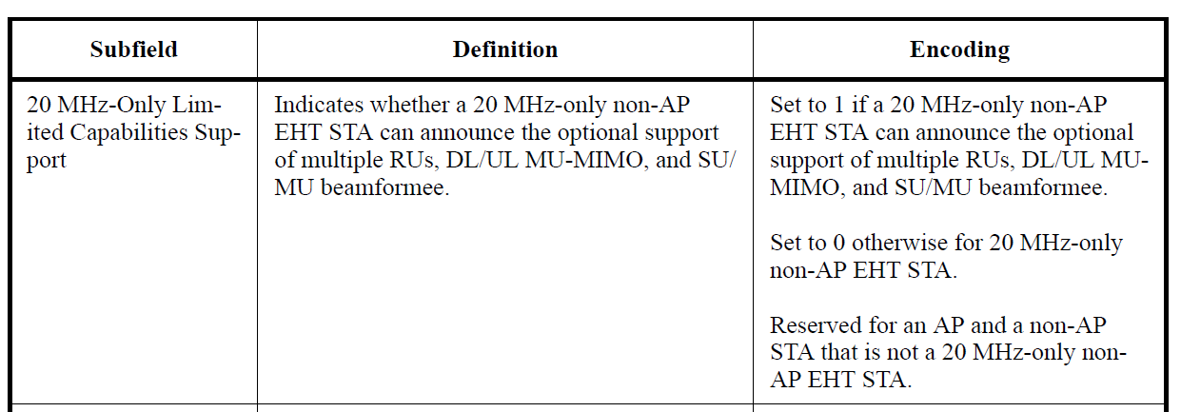

- TGbf Editor: Change Figure 9-1001bi—Sensing field format (p.77 in 11bf D3.0):
Rename “Reserved” field to “20MHz Sensing Transmitter Only”

- TGbf Editor: Add following paragraph at end of subclause 9.4.2.321 Sensing Capabilities element (p.79, l.5 in 11bf D3.0):
The 20MHz Sensing Transmitter Only field is set to 1 by a non-AP STA responder to indicate to an initator that it only supports the sensing transmitter role in a 20 MHz bandwidth, not the sensing receiver role nor any larger bandwidth. For an AP the 20MHz Sensing Transmitter Only field is reserved.

- TGbf Editor: Add following paragraph to subclause 11.55.1.3 Sensing capabilities exchange (p.139, l.58 in 11bf D3.0):
- A non-AP STA that has set the the 20MHz Sensing Transmitter Only field in the Sensing Capabilities element to 1, shall set the BW field in the Sensing Capabilities element to 0.

- TGbf Editor: Add following paragraph to subclause 11.55.1.4.1 General (p.141, l.45 in 11bf D3.0):
If a sensing responder has set the 20MHz Sensing Transmitter Only subfield in the Sensing Capabilities element to 1, then the sensing initiator shall assign the sensing responder to a sensing transmitter role only.

