IEEE P802.11
Wireless LANs
RESOLUTIONS OF CIDs 7082, 7071, 7077
Date: 2024-3-11
Author(s):
Name | Affiliation | Address | Phone | email
Graham SMITH | SR Technology | Sunrise, FL, USA. | 916 799 9563 | gsmith@srtrl.com
Abstract
This submission proposes resolution for CIDs 7082,7071, 7077

Green indicates material agreed to in the group,
yellow material to be discussed, red material rejected by the group and
cyan material not to be overlooked.

The “Final” view should be selected in Word.

V1 – Added reference for CID 7082

CID | Page | Clause | Resn Status | Comment | Proposed Change | Resolution | Owning Ad-hoc
7082 | 4880.38 | 31.6 |  | clause 6 issues- 6.3.127 doesn’t exist | as in comment. |  | MAC

4880.38
“If requested by a higher layer, an NGV STA with dot11RadioEnvironmentMeasurementPeriod not equal to
0 shall measure the channel busy percentage and report the measurement results to a higher layer as defined
in 6.3.127 (NGV radio environment measurement).

If requested by a higher layer, an NGV STA with dot11StationMeasurementPeriod not equal to 0 shall
measure the number of neighboring STAs (non-NGV STAs and NGV-STAs) and the number of
neighboring NGV STAs, and report these measurement results to a higher layer as defined in 6.3.127 (NGV
radio environment measurement).”

Discussion

First note that this text uses “shall” and “defined” with reference to Clause 6.3. This is discouraged as Clause 6.3 has the following introduction.
“These services are described in an abstract way (following the model described in ITU-T
Recommendation X.210 [B64]) and do not imply any particular implementation or exposed interface.”

802.11bd has Clause 6.3.127 “NGV radio environment measurement”
This provides details of the .request, and .indication making it a Type 3.
It also appears to provide details of the how to calculate the value which I can’t find in the text.
As per following example.

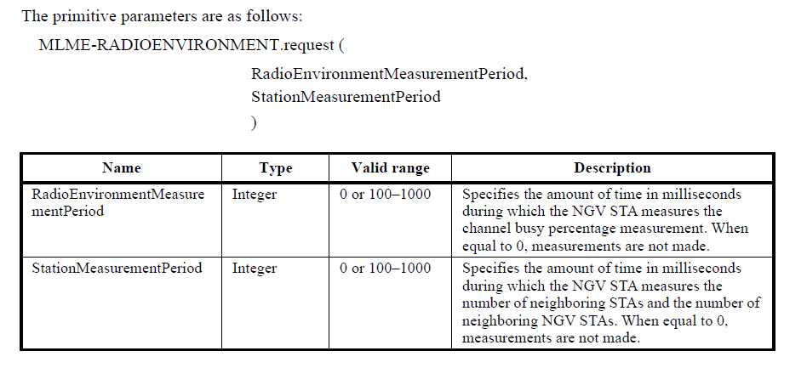

Hence a simple addition to the Table 6-1 is not enough. Ideally this should be described in text, but the easiest way is to add to Clause 6.5.

RESOLUTION
Revised

From 802.11bd-2022 take “Clause 6.3.127 NGV radio environment measurement” in its entirety.
Renumber as Clause 6.5.25 and add after Clause 6.5.24 reference to Draft P802.11 REVmd D 5.0.

THEN, add following to end of Table 6-1

Service Name | MLME-XXX | Type | References | Comments
NGV radio environment measurement | RADIOENVIRONMENT | 3 | 6.5.25 | See 31.6

NOTE to Editor: Table 6-1 is missing the P in SAP. Page 392.5.

AND
At 4880.38, replace “6.3.127” with “6.5.25”.
___________________________________________________________________________________________

CID | Page | Clause | Resn Status | Comment | Proposed Change | Resolution | Owning Ad-hoc
7077 | 2487.13 | 11.1.4.7 |  | Clause 6 issue - couldn’t find 6.3.128.5 | as in comment |  | MAC

2487.10
“When the STA receives one or more SSW frames with the OCB subfield equal to 1 during an A-BFT or DTI and completes SLS with the peer STA, and the address of the peer STA is an address that is newly discovered, the STA shall issue an MLME-OCB-DMGDISCOVERY.indication with the PeerInfoSet parameter including the PeerInfo vector defined in 6.3.128.5 (MLME-OCB-DMGDISCOVERY.indication) for the peer STA that transmitted the SSW frame.”

The text describes in detail the DMG-OCB-START.request, DMG-OCB-STOP.request and OCB-DMGDISCOVERY.indication where the cross reference to the original clause in 11bd is provided. Also OCB-LINKSTATUS.indication is described.

The text and Figures 11-14 and 11-15 are provided which explain the process in good detail so in this case I think we can simply use an addition to Table 6-1, but we do need to capture the details of the PeerInfo vector in the DMGDISCOVERY.indication.

RESOLUTION
Revised

Add at end of Table 6-1

Service Name | MLME-XXX | Type | References | Comments
DMG operation outside the context of a BSS | DMG-OCB-START | 4 | 9.3.4.2, 9.4.2.127, 9.4.2.265, 9.4.2.279. 9.4.2.25 | See 11.1.4.7
 | DMG-OCB-STOP | 6
 | OCB-DMGDISCOVERY | 7 | 9.4.2.25, 9.3.4.2, 9.5.3, 9.3.4.2, 9.4.2.127, 9.4.2.265
 | OCB-LINKSTATUS | 7 | 11.27.1.1, 9.4.2.25 | See 11.27.1.1

AND
At 2487.10 edit as follows:
“When the STA receives one or more SSW frames with the OCB subfield equal to 1 during an A-BFT or DTI and completes SLS with the peer STA, and the address of the peer STA is an address that is newly discovered, the STA shall issue an MLME-OCB-DMGDISCOVERY.indication with the PeerInfoSet parameter including the PeerInfo vector defined in 6.3.128.5 (MLME-OCB-DMGDISCOVERY.indication) for the peer STA that transmitted the SSW frame. Each PeerInfo vector consists of the parameters shown in Table 11.XX, in which the term peer STA refers to the STA that transmitted the received DMG Beacon frame, SSW frame, SSW Feedback frame, or
SSW Ack frame.”

AND
Add new Table 11.XX
Table 11.XX
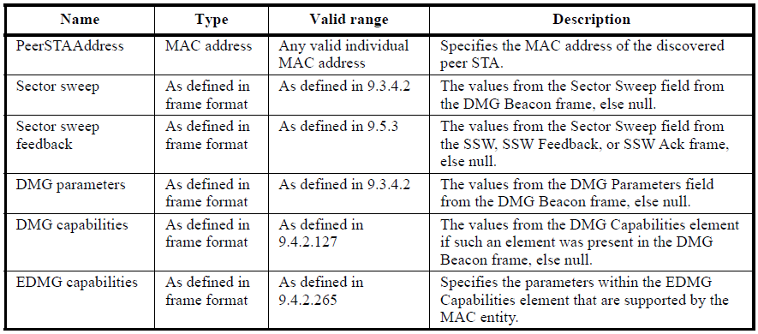

______________________________________________________________________________________________

CID | Page | Clause | Resn Status | Comment | Proposed Change | Resolution | Owning Ad-hoc
7071 | 1756.65 | 10.2.3.2 |  | 6.3.55(Timing measurement) was deleted in D2.0. The reference needs to be updated. | as in comment. |  | MAC

“NOTE—The values specified in the TOD and TOA fields are described in MLME_TIMINGSMSMT.request
MLME_TIMINGSMSMT.confirm and MLME_TIMINGSMSMT.indication primitives.(#1114-Ed1)

Editor’s Note: 6.3.55(Timing measurement) was deleted in D2.0. The reference needs to be updated”

Table of MLMEs is in Clause 6.4.

See page 399.51 for the TIMINGMSMT, Type 2 referencing 9.6.14.3 (Timing Measurement frame format)

Type 2 is request, indication, and confirm.

Is it TIMINGMSMT or TIMINGSMSMT? Table 6-1 does not have the “S”, but no matter as proposing to delete this reference.

In this case, simply need to delete the reference. Can add the frame format reference.

RESOLUTION
Revised
At 1756.64
“NOTE—See 9.6.14.3 (Timing Measurement frame format) for Tthe values specified in the TOD and TOA fields. are described in MLME_TIMINGSMSMT.request MLME_TIMINGSMSMT.confirm and MLME_TIMINGSMSMT.indication primitives

