IEEE P802.11
Wireless LANs
CR for miscellaneous CIDs
Date: 2024-03-04
Author(s):
Name | Affiliation | Address | Phone | email
Yunbo Li | Huawei |  |  | liyunbo@huawei.com
Ming Gan
Yuchen Guo
Guogang Huang
Zhenguo Du
Yue Zhao
Maolin Zhang
Stephen McCann
Edward Au
Abstract
This submission proposes comments resolution of the following 4 CIDs received for TGbe Draft 5.0:

CIDs:
22033
22189
22205
22294

Revisions:
- Rev 0: Initial version of the document.

TGbe editor: The baseline for this document is IEEE 802.11be D5.0

- Introduction

Interpretation of a Motion to Adopt

A motion to approve this submission means that the editing instructions and any changed or added material are actioned in the TGbe Draft. The introduction and the explanation of the proposed changes are not part of the adopted material.

CID | Commenter | Clause | P.L | Comment | Proposed Change | Resolution
22033 | Joseph Levy | 10.3.1 | 334.09 | The concept of NSTR is only applicable to MLDs and is adequately discuss in clause 35 and appendix AF. Therefore it should not be included in the general DCF discussion. | Remove all NSTR discussion from clause 10.3. In subclauses 10.3.1, 10.3.2.9, 10.3.2.11. | Rejected  While the behaviour description of a STA that is NSTR limited is discussed in clause 35, the texts in clauses 10.3.2.9 and 10.3.2.11 are needed to describe the scenario that excludes the STAs that are NSTR limited.  Current text put all DCF related procedure in one location which will easier for the reader to check.
22189 | John Wullert | 35.5.3 | 600.37 | The statement indicates that the EHT STA may set the parameter based on the functionality of the AP. However, the definition of dot11TwoBQRsOptionImplemented indicates that it represents the capability of the EHT STA, which should be independent of the AP to which it is associated. | Remove this sentence. If the intention of the requirement is to ensure that the EHT STA does not send the related fields to APs that do not support 320 MHz, then add that requirement to the next two sentences. | Revised  Agree with the commenter that the value of dot11TwoBQRsOptionImplemented is independent with the fuction of AP.  TGbe editor, please implement changes with tag 22189 as shown in 11-24/0358r0

TGbe editor: Modify the paragraphes in 35.5.3 (Operation of the two BQR Control subfields) as follows:

35.5.3 Operation of the two BQR Control subfields
An EHT STA may set dot11TwoBQRsOptionImplemented to true if it (#22189) supports 320 MHz.
An EHT STA with dot11TwoBQRsOptionImplemented equal to true shall set the Two BQRs Support subfield in the EHT MAC Capabilities Information field in the EHT Capabilities element it transmits to 1; otherwise, the EHT STA shall set the Two BQRs Support subfield to 0.
An EHT STA with dot11TwoBQRsOptionImplemented equal to true shall set the BQR Support subfield in the HE MAC Capabilities Information field in the HE Capabilities element it transmits to 1.
The EHT STA may report the channel availability information as specified in 36.3.21.6.4 (Per 20 MHz CCA sensitivity) to its associated AP in two BQR Control subfields of frames it transmits if the AP has indicated its support in the Two BQRs Support subfield of its EHT Capabilities element; otherwise, the STA shall not report the channel availability information in the two BQR Control subfields.

22205 | Osama Aboulmagd | 10.1 | 333.37 | The ML introduction has introduced major architectural issues. However Fig 10.1 hasn't been changed to accommodate those changes and illustrates how ML architecture fits in the overall architecture | Include ML architecture in Figure 10.1 as it fits | Rejected  For STAs in a STR link pair, the channel access follows the rules of a STA that is not affiliated with a MLD.  For STAs in a NSTR link pair, the task group discussed to add a box parallelly with HCCA, EDCA, MCCA and TUA to capature the new rules introcuded in clause 35, but the discussion didn’t reach any concensus.  (see https://mentor.ieee.org/802.11/dcn/21/11-21-0465-02-00be-cr-for-figure-10-1.docx)
22294 | Brian Hart | 35.2.1.2.3 | 494.38 | Since PHY-RXEND.indication occurs after aRxPHYDelay (see Figure 10-29), "The time allocation shall start when the PHY-RXEND.indication primitive of the PPDU that contains the MU-RTS TXS Trigger frame has occurred." is actually an implementation specific time and not suitable for standardization. | Try "The time allocation on the medium shall start aRxPHYDelay before the PHY-RXEND.indication primitive of the PPDU that contains the MU-RTS TXS Trigger frame has occurred." This might not be anti-causal since the RX can predict when PHY-RXEND will occur but anyway anti-causality doesn't matter here since really this is used to define the end of the time allocation | Revised  Agree with the commenter that the text is not correct based on the timing relatioinships of Figure 10-29 (EDCA mechanism timing relationships).  The D1 in Figure 10-29 referenced from the end of the last PPDU. The similar expression (“start from the end of the PPDU”) is used for simplicity.  TGbe editor, please implement changes with tag 22294 as shown in 11-24/0358r0

Discussion:
Figure 10-29 in IEEE802.11-REVme D4.1
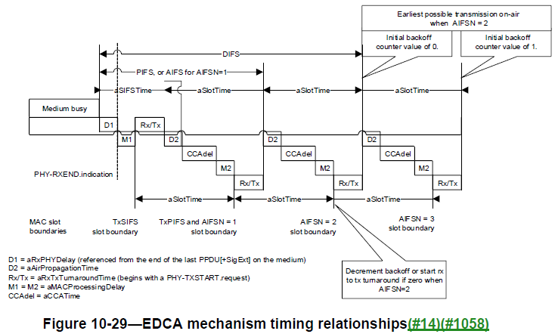

TGbe editor: Modify the paragraphes in 35.5.3 (Operation of the two BQR Control subfields) as follows:
35.2.1.2.3 Non-AP STA behavior
After a non-AP EHT STA receives an MU-RTS TXS Trigger frame from its associated AP that contains a User Info field that is addressed to it, the STA may transmit one or more non-TB PPDUs within the time allocation signaled in the MU-RTS TXS Trigger frame. The first PPDU of the exchange shall carry a CTS frame transmitted per the rules defined in 26.2.6.3 (CTS frame sent in response to an MU-RTS Trigger frame).

The time allocation shall start (#22294)from the end of the PPDU that contains the MU-RTS TXS Trigger frame.

End of change

