IEEE P802.11
Wireless LANs
Sounding Segmentation
Date: 2024-03-13
Author(s):
Name | Affiliation | Address | Phone | email
Youhan Kim | Qualcomm Technologies, Inc. |  |  | youhank@qti.qualcomm.com

Abstract
This submission proposes resolutions for the following comments from SB1 on P802.11be D5.0:

22373

NOTE – Set the Track Changes Viewing Option in the MS Word to “All Markup” to clearly see the proposed text edits.

Revision History:

R0: Initial version.

CID 22373

CID  Clause  Page.Line | Comment | Proposed Change
22373  35.7.4  621.34 | The text is unclear how MU feedback should be segmented. For example, in each segment, does EHT Compressed Beamforming/CQI frame need to include both EHT Compressed Beamforming Report and EHT MU Exclusive Beamforming Report? Or it may include EHT Compressed Beamforming Report and/or EHT MU Exclusive Beamforming Report? In other words, some EHT Compressed Beamforming/CQI frame may include EHT Compressed Beamforming Report only or EHT MU Exclusive Beamforming Report only? REVme passed changes in 11-24/0085r4 for CID 6006 which clarified the sounding feedback segmentation procedure for HE. The issue mentioned in CID 6006 also applies to EHT sounding feedback. Similar clarification should be provided for 11be. | REVme adopted changes proposed in 11-24/0085r4 for CID 6006 to clarify the sounding segmentation procedure for HE. Please adopt similar clarification for EHT sounding segmentation.

Discussion

Reusing the discussion in https://mentor.ieee.org/802.11/dcn/24/11-24-0085-04-000m-sb1-miscellaneous-cids.docx:

How the EHT sounding feedback segmentation is done is not very clearly described as the commenter has indicated. The commenter asks, for example, whether the MU type feedback is segmented in which of the following two ways.

(NOTE – While the figures below talk about “HE”, the same applies to “EHT” as well.)

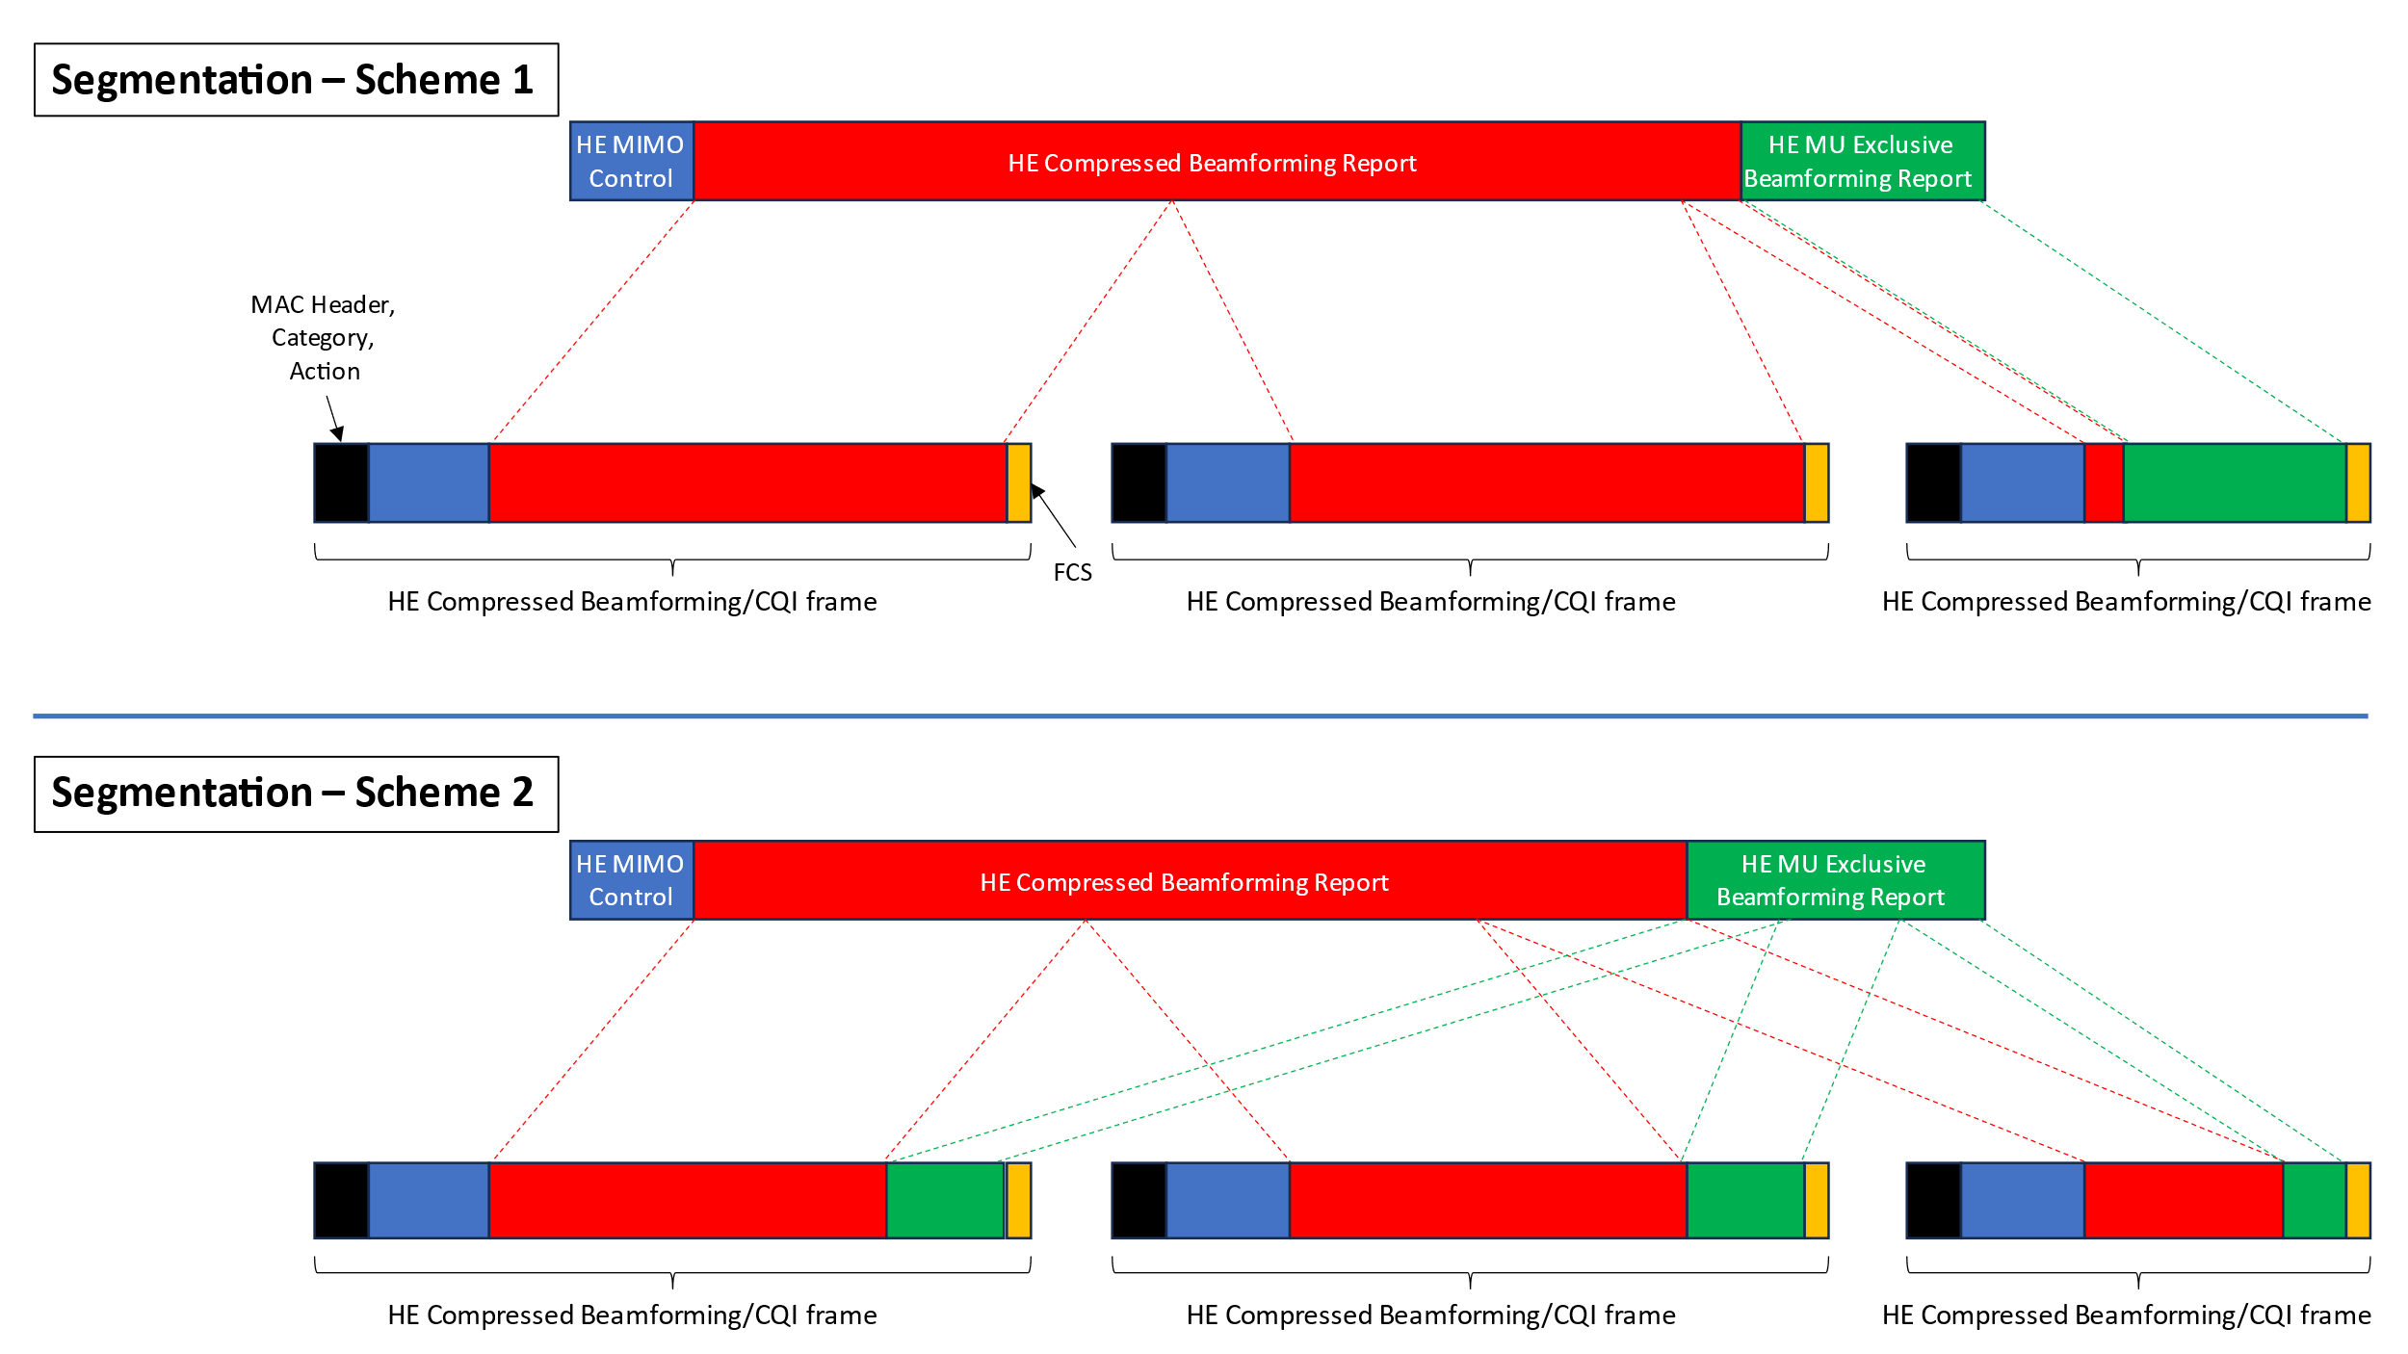

Correct approach is ‘scheme 1’ above.

The proposed text update creates two new ‘intermediate’ fields (EHT Compressed Beamforming/CQI Report, EHT Sounding Feedback Segement) to make the segmentation process clearer.

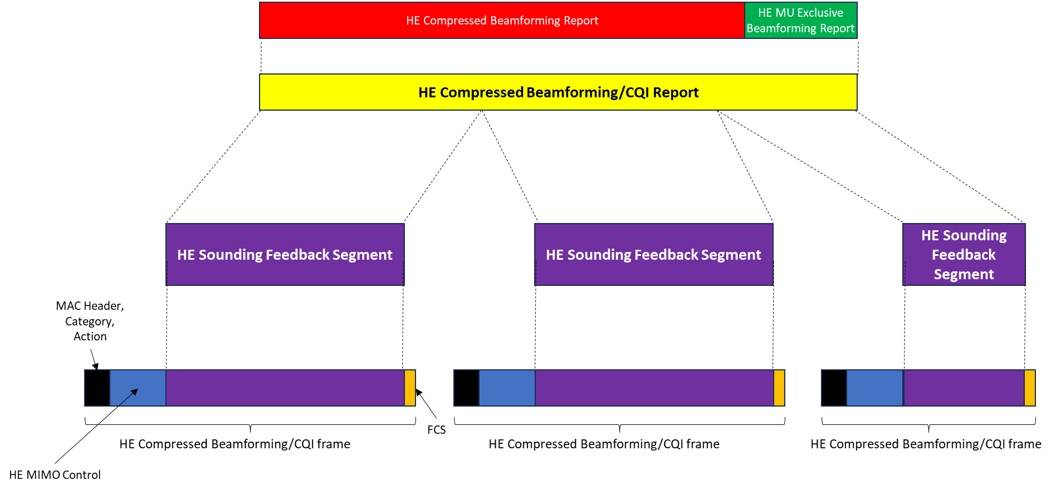

Proposed Resolution: CIDs 22373
REVISED

Instruction to TGbe Editor:
Implement the proposed text updates for CID 22373 in https://mentor.ieee.org/802.11/dcn/22/11-24-0329-00-00be-sb1-sounding-segmentation.docx

Note to Commenter:
The proposed text update provides mathematical description on how the EHT sounding feedback is segmented.

Proposed Text Updates: CIDs 22373

Instruction to TGbe Editor: Add the following at 11be D5.01 P209L58.

9.4.1.77a EHT Compressed Beamforming/CQI Report field

The EHT Compressed Beamforming/CQI Report field carries the EHT compressed beamforming/CQI report (see 35.7 (EHT sounding operation)) and is defined in Figure 9-206g.

 | EHT Compressed Beamforming Report | EHT MU Exclusive Beamforming Report | EHT CQI Report
Octets: | variable | variable | variable

Figure 9-206g – EHT Compressed Beamforming/CQI Report field format

The EHT Compressed Beamforming Report field is defined in 9.4.1.72 (EHT Compressed Beamforming Report field).

The EHT MU Exclusive Beamforming Report field is defined in 9.4.1.73 (EHT MU Exclusive Beamforming Report field).

The EHT CQI Report field is defined in 9.4.1.74 (EHT CQI Report field).

NOTE – The presence of the EHT Compressed Beamforming Report field, EHT MU Exclusive Beamforming Report field and EHT CQI Report field are dependent on the values of the Feedback Type subfield of the EHT MIMO Control field in the EHT Compressed Beamforming/CQI frame.

9.4.1.77b EHT Sounding Feedback Segment field

The EHT Sounding Feedback Segment field is defined in Figure 9-206h.

 | Sounding Feedback Segment
Octets: | Variable

Figure 9-206h – EHT Sounding Feedback Segment field format

The Sounding Feedback Segment field consists of octets number N1 to N2 (where the first octet is octet 1) of the EHT Compressed Beamforming/CQI Report field, where N1 and N2 are determined by the EHT MIMO Control field of the EHT Compressed Beamforming/CQI frame containing the EHT Sounding Feedback Segment field (see 35.7.4 (Rules for generating segmented feedback)).

Instruction to TGbe Editor: Update 11be D5.01 P317L35 as shown below.
9.6.37.2 EHT Compressed Beamforming/CQI frame format
The EHT Compressed Beamforming/CQI frame is an Action No Ack frame of category EHT. The Action field of an EHT Compressed Beamforming/CQI frame contains the information shown in Table 9-658b.
Table 9-658b – EHT Compressed Beamforming/CQI frame Action field format
Order | Information | Notes
1 | Category
2 | EHT Action
3 | EHT MIMO Control (see 9.4.1.71)
4 | EHT Sounding Feedback Segment (see 9.4.1.77b) | Optional
The Category field is defined in Table 9-81.
The EHT Action field is defined in Table 9-658a.

A Vendor Specific element is not present in the EHT Compressed Beamforming/CQI frame.

Instruction to TGbe Editor: Update 11be D5.01 P199L38 as shown below.

9.4.1.71 EHT MIMO Control field
…

Instruction to TGbe Editor: Update 11be D5.01 P199L56 as shown below.

9.4.1.72 EHT Compressed Beamforming Report field
…

The size of the EHT Compressed Beamforming Report field depends on the values in the EHT MIMO Control field. The EHT Compressed Beamforming Report field contains EHT Compressed Beamforming Report information. The EHT Compressed Beamforming Report field is included in the EHT Compressed Beamforming/CQI Report field (9.4.1.77a) if the Feedback Type subfield in the EHT MIMO Control field indicates SU or MU, and is not included otherwise.

Instruction to TGbe Editor: Update 11be D5.01 P203L54 as shown below.

9.4.1.73 EHT MU Exclusive Beamforming Report field
…

The size of the EHT MU Exclusive Beamforming Report field depends on the values in the EHT MIMO Control field. The EHT MU Exclusive Beamforming Report field contains EHT MU Exclusive Beamforming Report information. The EHT MU Exclusive Beamforming Report field is included in the EHT Compressed Beamforming/CQI Report field (9.4.1.77a) (in addition to the EHT Compressed Beamforming Report field) if the Feedback Type subfield in the EHT MIMO Control field indicates MU, and is not included otherwise.

Instruction to TGbe Editor: Update 11be D5.01 P204L33 as shown below.

9.4.1.74 EHT CQI Report field
…

The EHT CQI Report field contains EHT CQI Report information. EHT CQI Report information is included in the EHT Compressed Beamforming/CQI Report field (9.4.1.77a) if the Feedback Type subfield in the EHT MIMO Control field indicates CQI feedback, and is not included otherwise.

Instruction to TGbe Editor: Update 11be D5.01 P604L29 as shown below.

35.7 EHT sounding operation
35.7.1 General
…

The EHT beamformee returns an estimate of the channel state in an EHT compressed beamforming/CQI report carried in the EHT Compressed Beamforming/CQI Report field. There are three types of EHT compressed beamforming/CQI report:

- SU feedback: The EHT Compressed Beamforming/CQI Report field consists of an EHT Compressed Beamforming Report field.
- MU feedback: The EHT Compressed Beamforming/CQI Report field consists of an EHT Compressed Beamforming Report field and EHT MU Exclusive Beamforming Report field.
- CQI feedback: The EHT Compressed Beamforming/CQI Report field consists of an EHT CQI Report field.

NOTE—Use of EHT TB sounding does not necessarily imply MU feedback. EHT TB sounding is also used to obtain SU feedback and CQI feedback.

TheEHT Compressed Beamforming/CQI Report field is carried in a single EHT Sounding Feedback Segment fieldif the resulting EHT Compressed Beamforming/CQI frame is less than or equal to 11 454 octets in length (see 35.7.3 (Rules for EHT sounding protocol sequences)). Otherwise, the EHT Compressed Beamforming/CQI Report field is segmented, with each segment carried in an EHT Sounding Feedback Segment field, and each EHT Sounding Feedback Segment field carried in separate EHT Compressed Beamforming/CQI frames.

An EHT beamformer shall support a maximum MPDU length for the EHT Compressed Beamforming/CQI Report frame that is the minimum of 11 454 octets and the maximum length of the EHT Compressed Beamforming/CQI Report frame that the EHT beamformer intends to solicit from its HE beamformee(s).

35.7.3 Rules for EHT sounding protocol sequences
…

Instruction to TGbe Editor: Update 11be D5.01 P621L55 as shown below.
If the EHT beamformee receives a BFRP Trigger frame with a matching STA Info field, the EHT beamformee transmits an EHT TB PPDU containing the EHT compressed beamforming/CQI report following the rules defined in 35.5.2.3 (Non-AP STA behavior for UL MU operation). If the EHT NDP Announcement frame has the TA field set to the transmitted BSSID, and the EHT beamformee is a non-AP STA associated with an AP corresponding to a nontransmitted BSSID that supports receiving Control frames with TA field set to the transmitted BSSID, then the EHT Compressed Beamforming/CQI frame(s) sent in response shall have the RA field set to as defined in 26.5.2.3.5 (RA field for frames carried in an HE TB PPDU).

NOTE 2—A non-AP EHT beamformee that transmits an OM Control subfield with the UL MU Disable field set to 1 does not respond to BFRP Trigger frames (see 35.9 (Operating mode indication)).

An EHT beamformee that is a non-AP STA that transmits an EHT Compressed Beamforming/CQI frame shall set the Partial BW Info subfield of the EHT MIMO Control field to indicate the range of subcarriers for which compressed beamforming/CQI information is provided. The Partial BW Info subfield shall be set to the value of the Partial BW Info subfield of the NDP Announcement frame for the EHT beamformee.

Instruction to TGbe Editor: Update 11be D5.01 P622L16 as shown below.

35.7.4 Rules for generating segmented feedback

The EHT Sounding Feedback Segment field consists of bits in octet number N1 to octet number N2 of the EHT Compressed Beamforming/CQI Report field (see 9.4.1.77a (EHT Compressed Beamforming/CQI Report field)). Let L_{HCBCR} denote the length of the EHT Compressed Beamforming/CQI Report field in octets.

If the EHT Compressed Beamforming/CQI Report field would result in an EHT Compressed Beamforming/CQI frame that does not exceed 11 454 octets in length, then the EHT Compressed Beamforming/CQI Report field shall be included in a single EHT Sounding Feedback Segment field. In this case, N1 = 1 and N2 = L_{HCBCR} for the EHT Sounding Feedback Segment field.

If the EHT Compressed Beamforming/CQI Report field would result in an EHT Compressed Beamforming/CQI frame that exceeds 11 454 octets in length, then theEHT Compressed Beamforming/CQI Report field shall be split into K EHT Sounding Feedback Segment fields. Let L be the length of the EHT Sounding Feedback Segment field in octets that results in the length of the EHT Compressed Beamforming/CQI frame being 11 454 octets (see NOTE 1). Then, the number of EHT Sounding Feedback Segment fields is K = Ceil( L_{HCBCR} / L ) (see NOTE 2). For the k-th EHT Sounding Feedback Segment field that is not the last EHT Sounding Segment field (k = 1, …, K–1), N1 = (k–1) × L + 1 and N2 = k × L. For the last EHT Sounding Segment field, N1 = (K–1) × L + 1 and N2 = L_{HCBCR} (see NOTE 3). Each EHT Sounding Feedback Segment field shall be included in a separate EHT Compressed Beamforming/CQI frame. Each EHT Sounding Feedback Segment field is identified by the value of the Remaining Feedback Segments subfield and the First Feedback Segment subfield in the EHT MIMO Control field in the EHT Compressed Beamforming/CQI frame containing the EHT Sounding Feedback Segment field as defined in 9.4.1.71. The other nonreserved subfields of the EHT MIMO Control field shall be the same for all EHT Compressed Beamforming/CQI frames carrying different EHT Sounding Feedback Segment fields of the same EHT Compressed Beamforming/CQI Report field. All EHT Compressed Beamforming/CQI frames carrying different portions of the same EHT Compressed Beamforming/CQI Report field shall be sent in a single A-MPDU contained in a single PPDU and shall be included in the A-MPDU in the descending order of the Remaining Feedback Segments subfield values.

NOTE 1 – An EHT Sounding Feedback Segment field together with the other fields in the Frame Body field of the EHT Compressed Beamforming/CQI frame (see Figure 9-128 (Management frame format) and Table 9-658b (EHT Compressed Beamforming/CQI frame Action field format), constitutes a single unfragmented MMPDU.

NOTE 2 – The maximum length of the EHT Compressed Beamforming/CQI Report field is 60 008 octets (320 MHz MU type feedback with 8 columns, 8 rows, Ng = 4 and (ϕ, ψ) = {9, 7} bits – see Table 9-129a (EHT MIMO Control field encoding)). Therefore, the maximum number of the EHT Compressed Beamforming/CQI frames needed to carry an EHT Compressed Beamforming/CQI Report field is 6.

NOTE 3 – This results in all EHT Sounding Feedback Segment fields that are not the last EHT Sounding Segment field to have equal length. All EHT Compressed Beamforming/CQI frames that do not contain the last EHT Sounding Feedback Segment field have equal length of 11 454 octets. The last EHT Sounding Feedback Segment field might have length smaller than the other EHT Sounding Feedback Segment fields. The EHT Compressed Beamforming/CQI frame containing the last EHT Sounding Feedback Segment field has a length less than or equal to 11 454 octets.

An EHT beamformer that sends a BFRP Trigger frame to retrieve an EHT compressed beamforming/CQI report from an EHT beamformee shall solicit all possible EHT Sounding Feedback Segment fields (feedback segments) by setting all of the bits in the Feedback Segment Retransmission Bitmap subfield to 1 in the User Info field identifying the EHT beamformee.

An EHT beamformer that fails to receive some or all of the feedback segments of the EHT compressed beamforming/CQI report from the EHT beamformee shall not use a BFRP Trigger frame to request retransmission of the feedback segments. In this case, the EHT beamformer may repeat the entire sounding sequence.

[End of File]

