IEEE P802.11
Wireless LANs
ISB CR for CID 22390
Date: Feb. 23, 2024
Author(s):
Name | Affiliation | Address | Phone | email
Jason Yuchen Guo | Huawei |  |  | guoyuchen@huawei.com
Ming Gan | Huawei
Yunbo Li | Huawei
Guogang Huang | Huawei
Mengyao Ma | Huawei
Yue Zhao | Huawei
Maolin Zhang | Huawei

Abstract
This submission proposes resolutions for following CID received for TGbe initial SA ballot :
22390
Revisions:
- Rev 0: Initial version of the document.

Interpretation of a Motion to Adopt

A motion to approve this submission means that the editing instructions and any changed or added material are actioned in the TGbe Draft. This introduction is not part of the adopted material.

Editing instructions formatted like this are intended to be copied into the TGbe Draft (i.e. they are instructions to the 802.11 editor on how to merge the text with the baseline documents).

TGbe Editor: Editing instructions preceded by “TGbe Editor” are instructions to the TGbe editor to modify existing material in the TGbe draft. As a result of adopting the changes, the TGbe editor will execute the instructions rather than copy them to the TGbe Draft.

CID | Commenter | Clause | Page | Comment | Proposed Change | Resolution
22390 | Xiangxin Gu | 26.5.2.3 | 485.56 | "A non-AP HE STA may ignore B0 in an HE variant User Info field in a Trigger frame." is not correct. The B0 in an HE variant User Info field is part of AID12, it makes no sense for a non-AP HE STA to ignore it. By checking previous draft, the bit needed be ignored is the B0 of RU Allocation which is B12 of HE variant User Info field. | Change "A non-AP HE STA may ignore B0 in an HE variant User Info field in a Trigger frame." to "A non-AP HE STA may ignore B0 of RU Allocation subfield in an HE variant User Info field in a Trigger frame.", or "A non-AP HE STA may ignore B12 in an HE variant User Info field in a Trigger frame.". | Revised  Agree in principle with the comment. This rule only applies to MU-RTS.  TGbe Editor: please implement the changes in this document tagged as #22390.

Discussions:
Text in Draft P802.11REVme_D5.0:
9.3.1.22 Trigger frame format
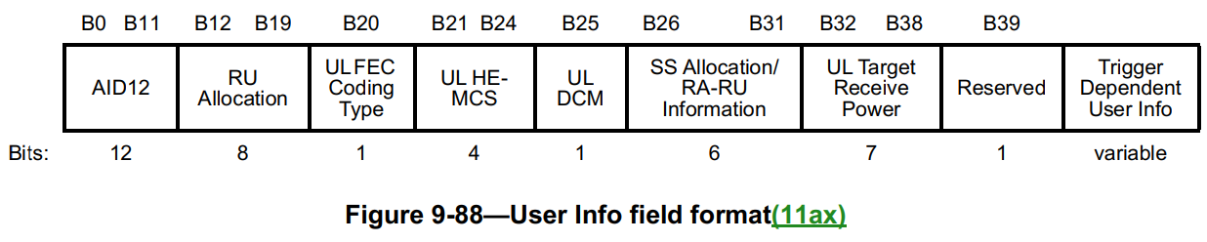

9.3.1.22.5 MU-RTS Trigger frame format
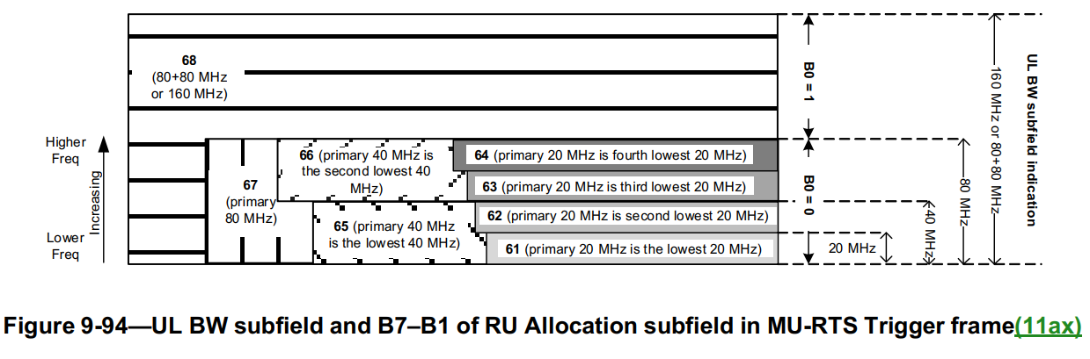

TGbe editor: Please update the following paragraphs in this subclause as shown below:
26.5.2.3 Non-AP STA behavior for UL MU operation
26.5.2.3.1 General
Insert the following paragraph at the end of the subclause:
(#22390)A non-AP HE STA may ignore B0 of the RU Allocation subfield in an HE variant User Info field in an MU-RTSframe.
……

