IEEE P802.11
Wireless LANs
Initial SA Ballot CR for CID 22159
Date: 2024-03-06
Author(s):
Name | Affiliation | Address | Phone | email
Juseong Moon | KNUT |  |  | jsmoon0211@a.ut.ac.kr
Ronny Yongho Kim | KNUT |  |  | ronnykim@ut.ac.kr
Woojin Ahn | KNUT |  |  | woojin.ahn@ut.ac.kr
Gwangho Lee | KNUT |  |  | gwangho.lee@a.ut.ac.kr
Abstract
This submission proposes comment resolution for CID 22159 received in initial SA ballot of 11be.

R0: Initial version.

Related Comment
CID | Commenter | Clause | P.L | Comment | Proposed Change | Resolution
22159 | Juseong Moon | 35.3.16.4 | 566.61 | In an AP MLD, which is associated with STA MLDs operating on an NSTR link pair, while backoff counter is zero and queue is being considered empty, another frame, destined to other STA not causing NSTR interference, can be queued and the EDCA queue becomes non-empty again. In this case, the data frame can be transmitted immediately without invoking new backoff because the backoff counter is already 0. Because this is the AP MLD's operation, it can enhance efficiency of AP MLD's transmission. However, draft 3.0 requires to invoke new backoff procedure for the AP MLD. It is more efficient to transmit a frame which doesn't cause interference without backoff, for the AP MLD. | Modify the text as following: — consider the transmit queue for that AC as empty until any frame exists in the queue which if transmitted, the transmitter determines, will not cause an unacceptable level of interference caused by transmission at the non-AP STA operating on the other link of an NSTR link pair that the AP or non-AP STA belongs to. The queue is then considered to have become nonempty and - the procedure described in 10.23.2.4 (Obtaining an EDCA TXOP) is followed for the AP if the transmit queue becomes nonempty due to an MPDU destined to another non-AP STA to be queued for transmission. - backoff is invoked per the procedure described in a) of 10.23.2.2 (EDCA backoff procedure) regardless of whether the medium is busy or not, otherwise. | Revised.  Agree in principle.  TGbe Editor: Apply the change tagged with #22159 to 11be D5.0.

Discussion
In 35.3.16.4 Nonsimultaneous transmit and receive (NSTR) operation of D5.0, the following 2 cases are not fully considered
Case 1: Frame transmission to the other non-AP MLD
The AP MLD’s queue becomes nonempty because the packet of same AC destined for the non-AP MLD 2 (different from non-AP MLD 1 which is currently transmitting) are enqueued.
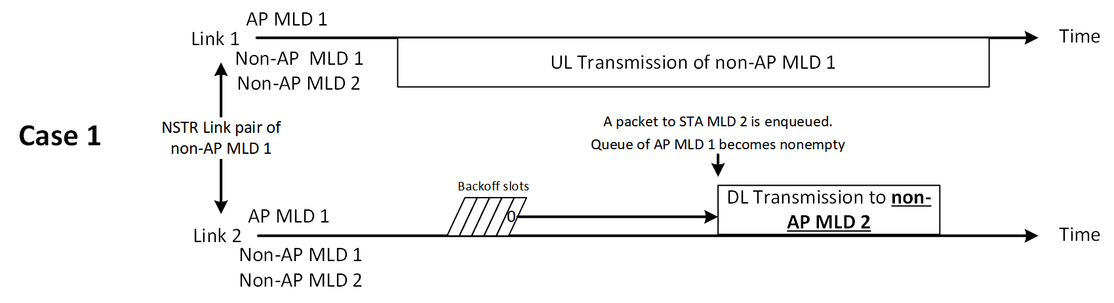
Case 2: Transmission procedure after the end of non-AP MLD’s transmission
The AP MLD’s queue becomes nonempty after the non-AP MLD 1’s uplink transmission ends. The non-AP MLD 1 will not transmit immediately in the link 2, because of two reasons. Firstly, the non-AP MLD shall start MediumSyncDelay timer. Secondly, based on current 11be NSTR operation, the non-AP MLD shall invoke new backoff in the link 2.
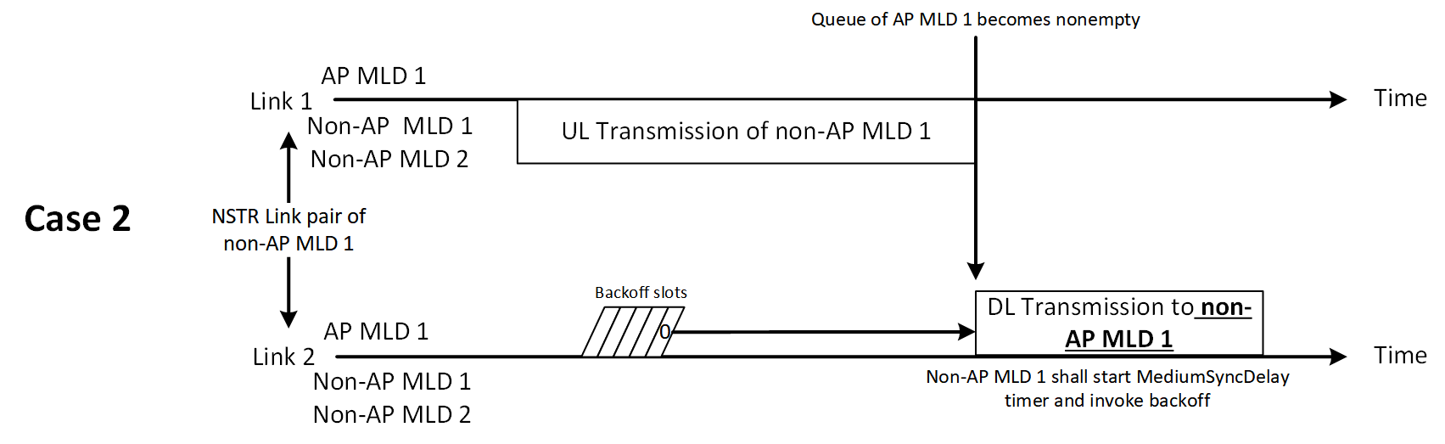

<Case 1: Packet to the other non-AP MLD>
- The AP MLD’s queue becomes nonempty because the packet of same AC destined for the non-AP MLD 2 (different from non-AP MLD 1 which is currently transmitting) are enqueued.
- In this case, the AP MLD 1 can transmit the frame to the non-AP MLD 2 without invoking new backoff.
- However, AP MLD has to invoke new backoff per Draft 5.0 as marked in blue below.
An AP or non-AP STA affiliated with an MLD that has gained the right to initiate the transmission of a frame as described in 10.23.2.4 (Obtaining an EDCA TXOP) for an AC but does not transmit any frame corresponding to that AC for the reasons stated above may:
— invoke a backoff for the EDCAF associated with that AC as allowed per h) of 10.23.2.2 (EDCA backoff procedure)
— consider the transmit queue for that AC as empty until any frame exists in the queue which if transmitted, the transmitter determines, will not cause an unacceptable level of interference caused by transmission at the non-AP STA operating on the other link of an NSTR link pair that the AP or non-AP STA belongs to. The queue is then considered to have become nonempty and backoff is invoked per the procedure described in a) of 10.23.2.2 (EDCA backoff procedure) regardless of whether the medium is busy or not

<Case 2: Transmission procedure after the end of non-AP MLD’s transmission>
- The AP MLD’s queue becomes nonempty after the non-AP MLD 1’s uplink transmission ends. The non-AP MLD 1 will not transmit immediately in the link 2, because of two reasons. Firstly, the non-AP MLD shall start MediumSyncDelay timer. Secondly, based on current 11be NSTR operation, the non-AP MLD shall invoke new backoff in the link 2.
- Therefore, even if the AP MLD does not invoke new backoff in the link 2, the AP MLD’s transmission will not collide with other non-AP STAs.
- However, AP MLD shall invoke new backoff per Draft 5.0.

Proposed Text for 11be D5.0

35.3.16.4 Nonsimultaneous transmit and receive (NSTR) operation
TGbe Editor: please apply the following change to P566L4 of 802.11be D5.0
— consider the transmit queue for that AC as empty until any frame exists in the queue that if
transmitted, the transmitter determines, will not cause an unacceptable level of interference caused
by transmission at the non-AP STA operating on the other link of an NSTR link pair that the AP or non-AP STA belongs to. The queue is then considered to have become nonempty and

- the procedure described in 10.23.2.4 (Obtaining an EDCA TXOP) is followed for the AP if the transmit queue becomes nonempty due to an MPDU destined to another non-AP STA to be queued for transmission.
- backoff is invoked per the procedure described in a) of 10.23.2.2 (EDCA backoff procedure) regardless of whether the medium is busy or not, otherwise.

