IEEE P802.11  
Wireless LANs

|  |  |  |  |  |
| --- | --- | --- | --- | --- |
| LB281 CR for 11.55.1.5.2.6 Reporting phase etc | | | | |
| Date: 2024-1-24 | | | | |
| Author(s): | | | | |
| Name | Affiliation | Address | Phone | email |
| Atsushi Shirakawa | Sharp Corporation |  |  | shirakawa.atsushi@ieee.org |
|  |  |  |  |  |

Abstract

This submission proposes resolutions for CID 4038, 4057, 4146, 4169, 4170, 4214, 4215, 4216, 4217, 4218, 4219, 4260 received for TGbf LB281

Revisions:

- Rev 0: Initial version of the document.

- Rev 1:

- Rev 2:

- Rev 3:

TGbf editor: The baseline for this document is basically 11bf D3.0

**Part1:**

|  |  |  |  |  |  |
| --- | --- | --- | --- | --- | --- |
| **CID** | **Commenter** | **Page** | **Comment** | **Proposed Change** | **Resolution** |
| 4214 | Dong Wei | 53.14 | Chains should be used instead of antennas. | Replace "antennas" with "chains" | Accepted. |
| 4217 | Dong Wei | 54.27 | Chains should be used instead of antennas. | Replace "antennas" with "chains" | Accepted. |
| 4218 | Dong Wei | 54.32 | Chains should be used instead of antennas. | Replace "antennas" with "chains" | Accepted. |
| 4219 | Dong Wei | 54.41 | Chains should be used instead of antennas. | Replace "antennas" with "chains" | Accepted. |
| 4260 | Dong Wei | 161.04 | Chain should be used instead of antenna. | Replace "antenna" with "chain" in the first three paragraphs of this clause (6 places) | Revised.  Commenter failed to indicate exact position to be modified because there is over six “antenna(s)” in the first three paragraphs.  And the word “antenna” should be kept in some places, like the word “antenna swapping”  See proposed text below <DCN0310r0> |

*CID4260:*

*TGbf Editor: Please modify P161L4 as follows: The baseline for this document is 11bf D3.0*

**11.55.1.5.4 Common rules**

The sensing receiver shall use the same ordered set of chains/antennas with no antenna swapping in the reception of

an SI2SR NDP, SR2SI NDP, or SR2SR NDP in all sensing measurement exchanges associated with the

sensing measurement session. If the CSI measurement at a receive ~~antenna~~ chain is invalid, then all CSI values

associated with that ~~antenna~~ chain shall be set to 0 in the MLME-SENSREPORT.indication primitive.

The sensing transmitter shall use the same ordered set of chains/antennas with no antenna swapping for transmission

of an SI2SR NDP, SR2SI NDP, or SR2SR NDP in all sensing measurement exchanges associated with

that sensing measurement session. If any of the transmit ~~antennas~~ chains is not available, the sensing transmitter

shall not transmit the SI2SR NDP, SR2SI NDP, or SR2SR NDP for that sensing measurement exchange.

NOTE—The sensing transmitter needs to terminate the sensing measurement session if any of its transmit chains/antennas is no

longer available for sensing measurements. If all transmit ~~antennas~~ chians of the sensing transmitter are no longer available for

sensing measurements, then the sensing measurement session is implicitly terminated.

NOTE—The sensing transmitter continues to use the same ordered set of chains/antennas with no antenna swapping even if it is

included in the TF sounding phase with UL MU-MIMO transmission with different assigned SS allocation in different

sensing measurement exchanges.

|  |  |  |  |  |  |
| --- | --- | --- | --- | --- | --- |
| **CID** | **Commenter** | **Page** | **Comment** | **Proposed Change** | **Resolution** |
| 4038 | Chaoming Luo | 155.64 | The note should be moved to P155L48. | As in commment. | Accepted |
| 4146 | Alireza Raissinia | 66.42 | Remove 'Nb' from the equation 9-5f and use the value 8 instead and modify the equation? | As per comment | Reviesed.  Nb was 8 or 10 bit in D2.1, but become only 8 with no choice in D3.0, so basically accepted.  Additionally, Nb appears in three places in D3.0, all of them should be removed and replaced to value 8.  See proposed text below <DCN0310r0> |

*CID4146:*

*TGbf Editor: Please modify P53L28 as follows: The baseline for this document is 11bf D3.0*

c) Each real and imaginary part of the CSI is scaled and quantized to *~~Nb~~* 8 bits using Equation (9-5c) and

Equation (9-5d), respectively.

*TGbf Editor: Please modify the equation 9-5f in P66L42, replace blue squared part to blue highlighted one: The baseline for this document is 11bf D3.0*



( 2 x T_TX x N_RX x N_SC )

*TGbf Editor: Please remove the paragraphy in P137L54 as follows: The baseline for this document is 11bf D3.0*

~~A sensing STA shall support~~ *~~Nb = 8~~* ~~in the Sensing Measurement Report frame (see Table 9-127h (Sensing~~

~~Measurement Report Control field definition)).~~

|  |  |  |  |  |  |
| --- | --- | --- | --- | --- | --- |
| **CID** | **Commenter** | **Page** | **Comment** | **Proposed Change** | **Resolution** |
| 4169 | Alireza Raissinia | 157.23 | Change "RU" to "UL resources" | As per comment | Accepted. |
| 4170 | Alireza Raissinia | 157.24 | Change the text "threshold-based reporting phase" to "measurement reporting subphase" | As per comment | Accepted. |

|  |  |  |  |  |  |
| --- | --- | --- | --- | --- | --- |
| **CID** | **Commenter** | **Page** | **Comment** | **Proposed Change** | **Resolution** |
| 4215 | Dong Wei | 53.14 | The positive scaling factor should be quantized. | Add "12-bit" before "positive scaling factor" | Rejected.  According to resolution to CID4216, readers would refer to Table 9-127k and understand positive scaling factor has 12bit quantization. So no need to have further modification. |
| 4216 | Dong Wei | 53.15 | The reference "9.4.1.73 (Sensing Measurement Report Container field)" is incorrect. | Delete the reference | Revised.  Reference should be “9.4.1.73.4 (Sensing Measurement Report field)” |

*CID4216:*

**FYI:**

Commenter pointed out the reference to subclause 9.4.1.73 is not appropriate. More preceisely subclause 9.4.1.73.4 should be referred to because there is the table 9-127k and corresponding description about scaling factor γ(r, t).

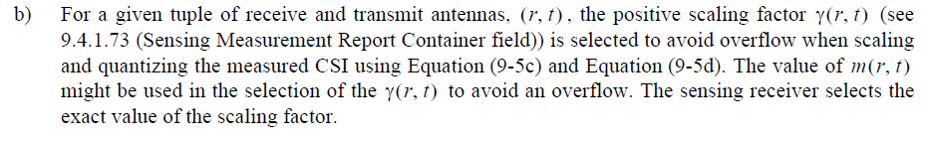

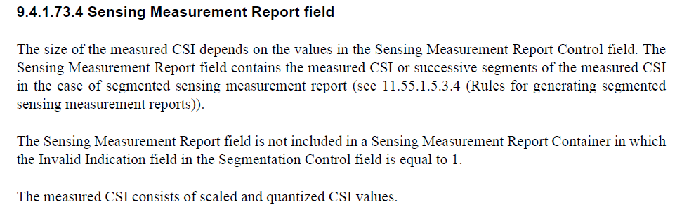

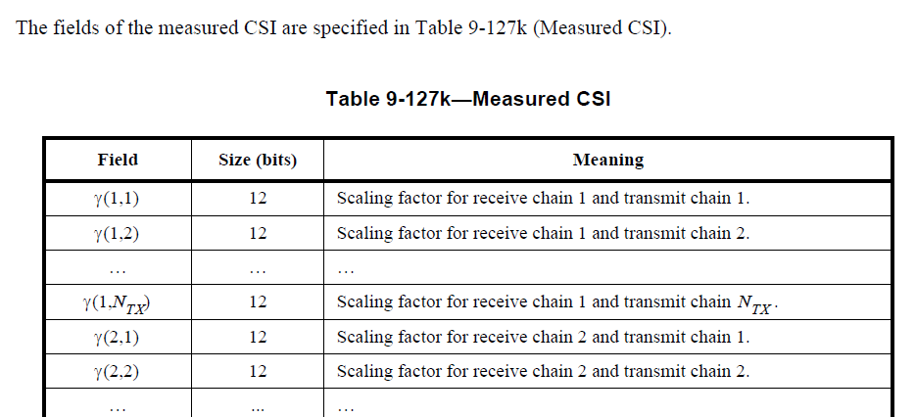

|  |  |  |  |  |  |
| --- | --- | --- | --- | --- | --- |
| **CID** | **Commenter** | **Page** | **Comment** | **Proposed Change** | **Resolution** |
| 4057 | Chaoming Luo | 156.04 | Suggest to use the term "sensing receiver" instead of "sensing responder" in clause 11.55.1.5.2.6.2 Threshold-based reporting phase. Two reasons: 11.55.1.5.2.6.1 Basic reporting phase use "sensing receiver"; The term "sensing responder" may be misleading to a sensing transmitter may also participate in the Threshold-based reporting phase. | As in comment. | Revised.  Follow similar description in 11.55.1.5.2.6.1 Basic reporting phase.  See proposed text below <DCN0310r0> |

*CID4057:*

*TGbf Editor: Please modify P156L4 as follows: The baseline for this document is 11bf D3.0*

**11.55.1.5.2.6.2 Threshold-based reporting phase**

Implementation of threshold-based reporting is optional. If implemented, for a sensing responder that is a sensing receiver, the threshold-based reporting shall

be only present in TB sensing measurement exchanges for the measurement session established with the CSI

Variation Threshold field in the TB Sensing Specific subelement set to a value in the range of 0 to 10 as part

of the Sensing Measurement Request frame.

**FYI:**

**11.55.1.5.2.6.1 Basic reporting phase**

*For a sensing responder that is a sensing receiver,* the basic reporting phase shall be present in a TB sensing

measurement exchange if the Sensing Measurement Report Requested field within the Sensing Measurement

Request frame is set to 1.

**SP**

Do you agree to the resolution provided for following CID 4038, 4057, 4146, 4169, 4170, 4214, 4215, 4216, 4217, 4218, 4219, 4260 to be included in the latest 11bf Draft?