IEEE P802.11
Wireless LANs
LB281 comment resolutions for OST CIDs Part 2
Date: 2024.02.28
Author(s):
Name | Company | Address | Phone | email
Zhuqing Tang | Huawei Technologies | Huawei Base, Shenzhen, Guangdong, China |  | tangzhuqing@huawei.com
Rui Du
Narengerile
Yiyan Zhang
Abstract
This submission contains the proposed comment resolutions for the CIDs: 4022, 4023, 4024, 4025, 4072, 4159, 4161, 4252.

R0: initial document
R1: modify the text under CIDs 4023, 4024, 4025

CIDs 4022, 4072

CIDs | Commenter | Page.  Line | Clause Number | Comment | Proposed Change | Resolution
4022 | Chaoming Luo | 142.12 | 11.55.1.4.1 | Use complete name, change to "until the sensing measurement session is terminated" | As in comment. | Accepted
4072 | Stephan Sand | 142.38 | 11.55.1.4.1 | The sentence starting on P142L38 is grammatically incorrect | Please replace "containing" with "contains" | Accepted

Discussion

For reference:

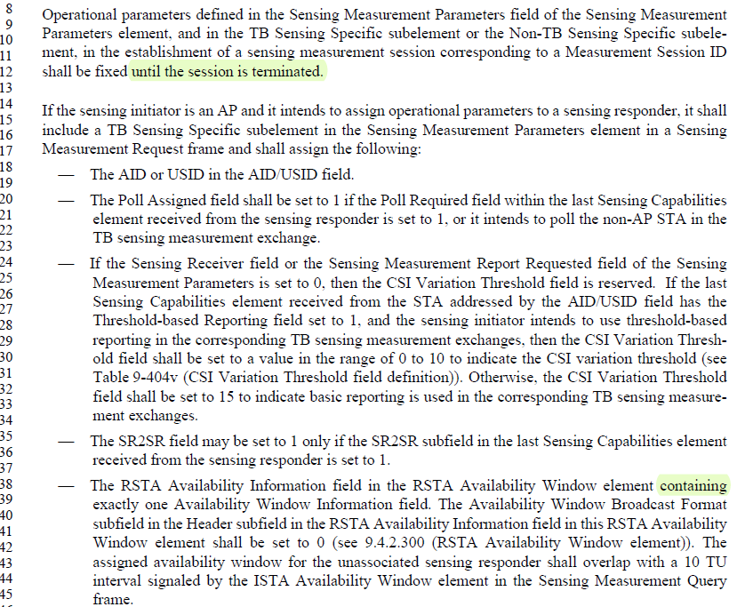

CIDs 4023, 4024, 4025

CID | Commenter | Page.  Line | Clause Number | Comment | Proposed Change | Resolution
4023 | Chaoming Luo | 142.25 | 11.55.1.4.1 | Use normative text, change to "then the CSI Variation Threshold field shall be reserved" | As in comment. | Accepted
4024 | Chaoming Luo | 142.28 | 11.55.1.4.1 | Suggest to add reference for threshold-based  reporting since this is the first appearance. | Change to "and the sensing initiator intends to use threshold-based reporting (see 11.55.1.5.2.6.2  (Threshold-based reporting phase)) in the corresponding TB sensing measurement exchanges" | Accepted
4025 | Chaoming Luo | 142.33 | 11.55.1.4.1 | Suggest to add reference for basic reporting since this is the first appearance. | Change to "and the sensing initiator intends to use threshold-based reporting (see 11.55.1.5.2.6.1 (Basic reporting phase)) in the corresponding TB sensing measurement exchanges" | Revised  TGbf Editor make changes specified in 24/0302r1.  (https://mentor.ieee.org/802.11/dcn/24/11-24-0302-01-00bf-lb281-comment-resolutions-for-ost-cids-part-2.docx)

Instructions to the editor: please make the following changes to the paragraph from P142L24 to P142L33 in the subclause 11.55.1.4.1 General as shown below:

— If the Sensing Receiver field or the Sensing Measurement Report Requested field of the Sensing Measurement Parameters is set to 0, then the CSI Variation Threshold field shall be reserved. If the last Sensing Capabilities element received from the STA addressed by the AID/USID field has the Threshold-based Reporting field set to 1, and the sensing initiator requests to use threshold-based reporting (see 11.55.1.5.2.6.2 (Threshold-based reporting phase)) in the corresponding TB sensing measurement exchanges, then the CSI Variation Threshold field shall be set to a value in the range of 0 to 10 to indicate the CSI variation threshold (see Table 9-404v (CSI Variation Threshold field definition)). Otherwise, the CSI Variation Threshold field shall be set to 15 to indicate basic reporting (see 11.55.1.5.2.6.1 (Basic reporting phase)) is used in the corresponding TB sensing measurement exchanges.

CID 4159

CID | Commenter | Page.  Line | Clause Number | Comment | Proposed Change | Resolution
4159 | Alireza Raissinia | 115.31 | 9.6.7.56 | Add the phrase "during non-TB sensing measurement exchange" after the word 'non-AP STA'. | As per comment | Revised  Agree with the commenter in principle.  TGbf Editor make changes specified in 24/0302r1.  (https://mentor.ieee.org/802.11/dcn/24/11-24-0302-01-00bf-lb281-comment-resolutions-for-ost-cids-part-2.docx)

Discussion

For reference:

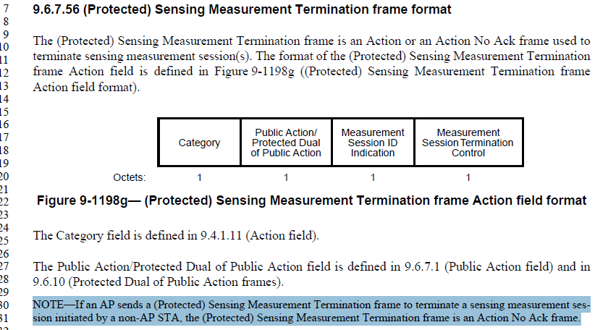

Instructions to the editor: please make the following changes to the paragraph of P115L31 in the subclause 9.6.7.56 (Protected) Sensing Measurement Termination frame format as shown below:

The Public Action/Protected Dual of Public Action field is defined in 9.6.7.1 (Public Action field) and in
9.6.10 (Protected Dual of Public Action frames).

NOTE—If an AP sends a (Protected) Sensing Measurement Termination frame to terminate a sensing measurement session initiated by a non-AP STA during a non-TB sensing measurement exchange, the (Protected) Sensing Measurement Termination frame is an Action No Ack frame.

CIDs 4161, 4252

CID | Commenter | Page.  Line | Clause Number | Comment | Proposed Change | Resolution
4161 | Alireza Raissinia | 140.26 | 11.55.1.4.1 | Delete the phrase "number of" as the field is defined without it. | As per comment | Accepted
4252 | Dong Wei | 140.21 | 11.55.1.4.1 | The constraint on the number of sensing sessions should be with respect to a single sensing responder. | Replace "sensing measurement sessions" with "concurrent sensing measurement sessions with the sensing responder" | Revised  Agree with the commenter in principle.  TGbf Editor make changes specified in 24/0302r1.  (https://mentor.ieee.org/802.11/dcn/24/11-24-0302-01-00bf-lb281-comment-resolutions-for-ost-cids-part-2.docx)

Discussion
For reference:
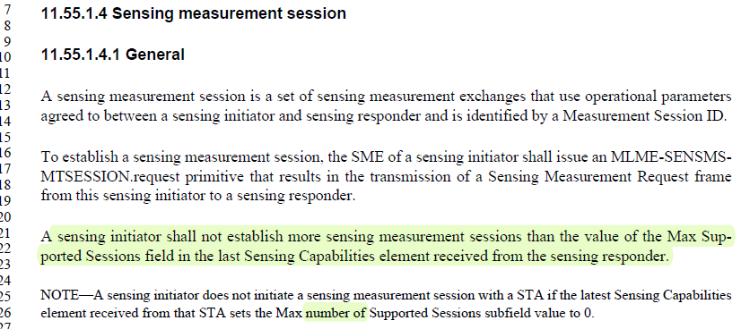

Instructions to the editor: please make the following changes to the paragraph from P140L21 to P140L26 in the subclause 11.55.1.4.1 General as shown below:

To establish a sensing measurement session, the SME of a sensing initiator shall issue an MLME-SENSMSMTSESSION. request primitive that results in the transmission of a Sensing Measurement Request frame from this sensing initiator to a sensing responder.

A sensing initiator shall not establish more concurrent sensing measurement sessions with a sensing responder than the value of the Max Supported Sessions field in the last Sensing Capabilities element received from the sensing responder.

NOTE—A sensing initiator does not initiate a sensing measurement session with a STA if the latest Sensing Capabilities element received from that STA sets the Max Supported Sessions subfield value to 0.

SP
Do you support resolutions to the following CIDs and incorporate the text changes into the latest TGbf draft: 4022, 4023, 4024, 4025, 4072, 4159, 4161, 4252 in 11-24/0302r1?

Y/N/A

