IEEE P802.11
Wireless LANs
LB279 comment resolutions for measurement sounding phase of TB ranging
Date: 2024-03-11
Author(s):
Name | Affiliation | Address | Phone | email
Stephan Sand | German Aerospace Center (DLR) |  |  | stephan.sand@ieee.org
Abstract
This submission discusses resolutions to the following 5 CIDs for measurement sounding phase of TB ranging from LB279 of TGbk D1.0.
The CID list is: 1059, 1080, 1113, 1123, 1125

Proposed changes in this document are with reference to TGbk D1.0, REVme D4.2, and TGbe D5.0.

Revisions:
- Rev 0: Intitial version of the document
- Rev 1: Changes discussed during 11bk March Plenary PM1 11.03.2024

Proposed comment resolution
Presented and discussed, no open discussion points
Under discussion
G/T must be satisfied comment

CID | Cat | Page | Comment | Proposed Change | Resolution
1123 | T | 34.01 | From the context, it looks like the requirement is on the RSTA to take an action based on receiptof the TF Ranging Sounding frame, not the frame itself. | Change  "If the bandwidth selected is 320 MHz in a measurement sounding phase, the TF Ranging 1 Sounding frame(s) in this measurement sounding phase shall solicit an EHT TB Ranging NDP. Otherwise, the TF Ranging Sounding frames(s) shall solicit an HE TB Ranging NDP.  If the Trigger frame Ranging Sounding is soliciting an HE TB Ranging NDP,"  to  "If the bandwidth selected is 320 MHz in a measurement sounding phase, the receipt of the TF Ranging 1 Sounding frame(s) in this measurement sounding phase shall solicit the transmission of an EHT TB Ranging NDP. Otherwise, the receipt of a TF Ranging Sounding frames(s) shall solicit the transmission of an HE TB Ranging NDP."  If the receipt of the Ranging Sounding Trigger frame is soliciting an HE TB Ranging NDP," | Rejected  The normative behavior is on the RSTA to transmit the correct Trigger Sounding frame format for soliciting EHT or HE TB Ranging NDP.

11bk D1.0: P34L1-7
If the bandwidth selected is 320 MHz in a measurement sounding phase, the TF Ranging Sounding frame(s) in this measurement sounding phase shall solicit an EHT TB Ranging NDP. Otherwise, the TF Ranging Sounding frames(s) shall solicit an HE TB Ranging NDP.

If the Trigger frame Ranging Sounding is soliciting an HE TB Ranging NDP, tThe RSTA shall set the TXVECTOR parameter CH_BANDWIDTH of the Trigger frame Ranging Sounding to that same bandwidth and use the same value for the UL BW subfield of the Common Info field of said Trigger frame.

CID | Cat | Page | Comment | Proposed Change | Resolution
1059 | T | 34.28 | Is this requirement only to be defined for HE-LTF symbols, or in general for LTF symbols | Please check if this is general text for LTF symbols and in case strike out "HE-" | Revised  TGbk editor:  Please replace P34L28-33 with the following text:  — (#1059) The product of the number of LTF repetitions, indicated in each of the I2R Rep subfields of the User Info fields, and the number of LTF symbols, indicated in the Number Of HE-LTF Symbols And Midamble Periodicity subfield in the HE variant Common Info field or in the Number Of HE/EHT-LTF Symbols subfield in the EHT variant Common Info field, shall not exceed the RSTA Assigned I2R LTF Total for any of the ISTA triggered by this Trigger frame.

11bk D1.0: P34L13-15 and L28-33
In the TF Ranging Sounding, the RSTA shall set the SS Allocation subfield and the I2R Rep subfield of the User Info fields corresponding to each of the ISTAs triggered by the Trigger frame in the following way:
…
— The product of the number of LTF repetitions, indicated in each of the I2R Rep subfields
of the User Info fields, and the number of HE-LTF symbols, indicated in the Number Of
HE-LTF Symbols And Midamble Periodicity subfield in the Common Info field, shall
not exceed the RSTA Assigned I2R LTF Total for any of the ISTA triggered by this
Trigger frame.

11be D5.0: Figure 9-87a HE variant Common Info field format and Figure 9-87b EHT variant Common Info field format
The HE variant Common Info field is defined in Figure 9-87a (HE variant Common Info field format).
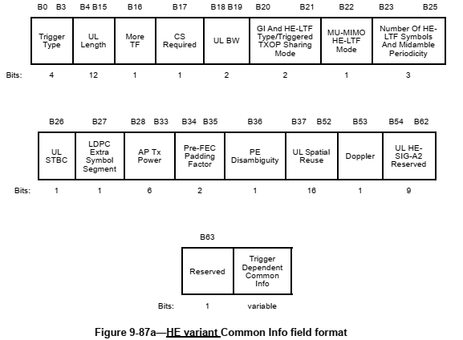
The EHT variant Common Info field is defined in Figure 9-87b (EHT variant Common Info field format).
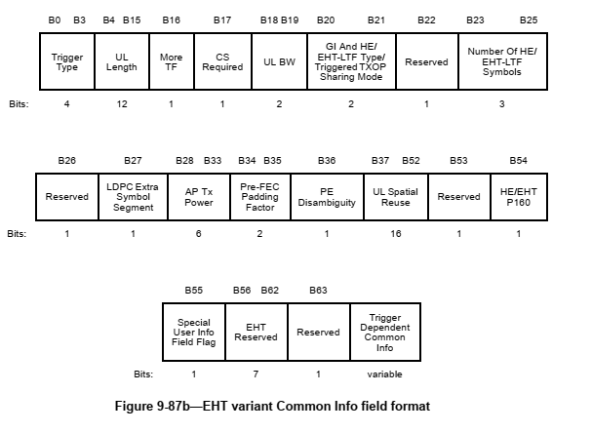

CID | Cat | Page | Comment | Proposed Change | Resolution
1125 | T | 35.30 | The sentence does not really make sense | Change  "The R2I NDP is transmitted SIFS after the Ranging NDP Announcement frame; if the bandwidth 30 is equal to 320 MHz, the R2I NDP shall be an EHT Ranging NDP, as described in 36.3.4.1 (EHT 31 Ranging NDP), otherwise the R2I NDP shall be an HE Ranging NDP."  to  "The R2I NDP is transmitted at a SIFS after the Ranging NDP Announcement frame; if the bandwidthis equal to 320 MHz, the R2I NDP shall be transmitted using an EHT Ranging NDP format, as described in 36.3.4.1 (EHT Ranging NDP). Otherwise the R2I NDP shall be transmitted as an HE Ranging NDP. | Revised  TGbk editor:  Please replace P35L30-32 with the following text:  (#1125) The R2I NDP is transmitted a SIFS after the Ranging NDP Announcement frame; if the bandwidth is equal to 320 MHz, the R2I NDP shall be transmitted as an EHT Ranging NDP, as described in 36.3.4.1 (EHT Ranging NDP). Otherwise the R2I NDP shall be transmitted as an HE Ranging NDP.

11bk D1.0: P34L13-15 and L28-33
The R2I NDP is transmitted SIFS after the Ranging NDP Announcement frame; if the bandwidth is equal to 320 MHz, the R2I NDP shall be an EHT Ranging NDP, as described in 36.3.4.1 (EHT Ranging NDP), otherwise the R2I NDP shall be an HE Ranging NDP.

CID | Cat | Page | Comment | Proposed Change | Resolution
1080 | T | 36.20 | Some modified text is not correctly highlighted with change bars, creating the impression it was there before. | See comment | Revised  Agree with comment.  TGbk editor:  Please underline all text on P36L19-21 and add at the beginning of P36L19 (#1080).

11bk D1.0: P36L19-21
— Begin with TB ranging measurement exchange that solicits EHT (TB) Ranging NDP, that
uses non-HT duplicate PPDU for the Ranging Trigger frames, and that sets the More TF
subfield to 1 in the Ranging Trigger frames.

CID | Cat | Page | Comment | Proposed Change | Resolution
1113 | T | 38.13 | "The uplink power control, timing and frequency synchronization requirements of unassociated STAs performing TB ranging shall follow the same rules as those of associated HE STAs."  Is this statement also applicable to EHT STAs? | Please replace "HE STAs" with "HE/EHT STAs" | Revised  TGbk editor:  Please replace "HE STAs" with "STAs" on P38L14 and add at the beginning of P38L13 (#1113).

11bk D1.0: P38L13-14
The uplink power control, timing and frequency synchronization requirements of unassociated STAs performing TB ranging shall follow the same rules as those of associated HE STAs.

