IEEE P802.11
Wireless LANs
LB279 Comment Resolution for CID 1016
Date: 2024-02-06
Author(s):
Name | Affiliation | Address | Phone | email
Shuling Julia Feng | Mediatek Inc | 2840 Junction Ave, San Jose, CA, USA |  | Julia.feng@mediatek.com
Abstract
This submission proposes resolution to CID 1016 submitted in LB279 on 11bk D1.0.

Revision history:
R0: Original version
R1: Change resolution to REJECTED with added reason, and add a reference to resolution of CID 1045 in 11-14/0215r2

CID | Clause | Page | Comment | Proposed change | Proposed resolution
1016 | 11.21.6.3.3 | 27.35 | In Table 11-14aa, "No puncturing" case with puncturing pattern [11111111] (4x996-tone RU1) is missing. | Add "No puncturing" case with puncturing pattern [11111111] (4x996-tone RU1) to Table 11-14aa | REJECTED  Please see discussions and reason to reject CID 1016 below this table.

CID 1016

Discussions:

The table commented and the related text to the table is written as follows on page 27 in 11bk D1.0,

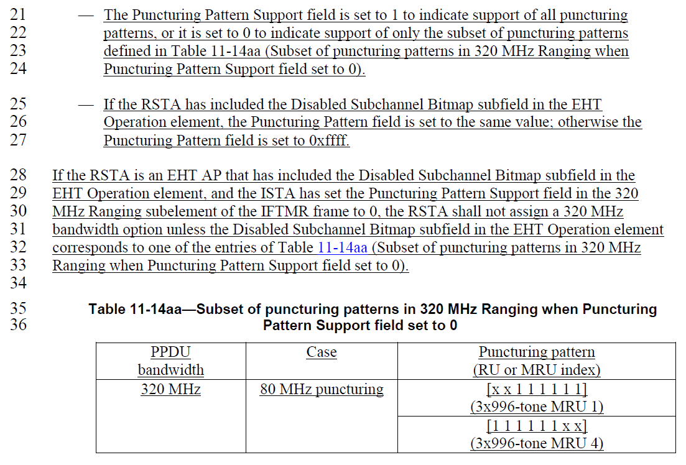

The Puncturing Pattern Support field is defined as follows on P25 in 11bk D1.0,

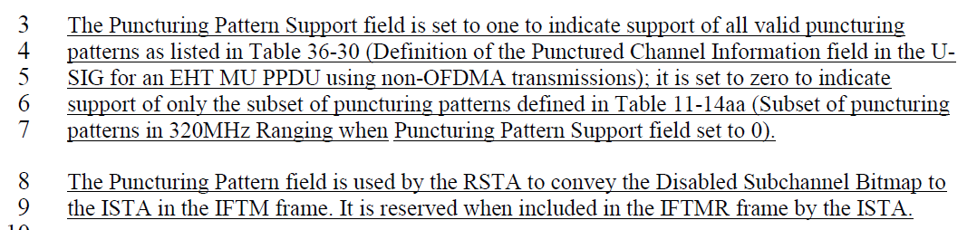

The Disabled Subchannel Bitmap subfield is defined as follows on P245 in 11be D5.0,

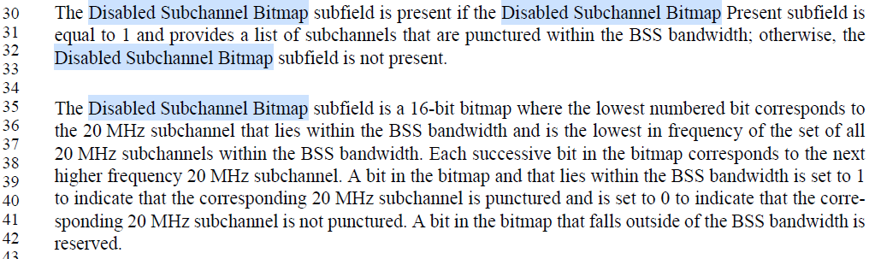

The Disabled Subchannel Bitmap subfield is also explained as follows on P649 in 11be D5.0.

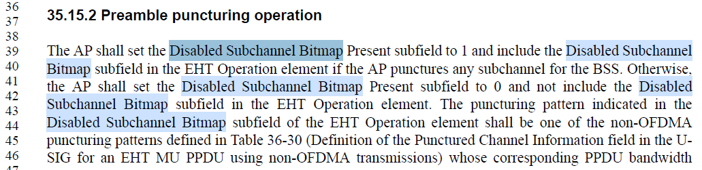

According to Clause 35.15.2, an EHT AP RSTA shall set Disabled Subchannel Bitmap Present subfield in EHT Operation element to 0 to indicate a countinuous 320MHz bandwidth. In other words, an EHT AP RSTA shall not include Disabled Subchannel Bitmap subfield in EHT Operation element if it operates a countinuous 320MHz bandwidth. The RSTA sets Puncturing Pattern field to 0xffff in the 320 MHz Ranging subelement, and the commented table is not applicable in this case.

The commented table and related text describe RSTA’s behavior when Disabled Subchannel Bitmap subfield is present and ISTA’s Puncturing Pattern Support field is set to 0. Since the puncturing patterns in Table 11-14aa are supported by the RSTA regardless of its Puncturing Pattern Support field value, this is the only case when the puncturing pattern is checked against this table. The description of RSTA behavior is complete.

Table 11-14aa is also commented in CID1045. Please refer to resolution of CID 1045 in 11-24/0215r2 for proposed modifications of this table and related text to clarify RSTA behavior description.

SP:

Do you agree to the resolutions provided for CID 1016 in 802.11-24/0278r0 to be included in 11bk Draft 2.0?

Y/N/A

