IEEE P802.11
Wireless LANs
LB279 Comment Resolution for CID 1016
Date: 2024-02-06
Author(s):
Name | Affiliation | Address | Phone | email
Shuling Julia Feng | Mediatek Inc | 2840 Junction Ave, San Jose, CA, USA |  | Julia.feng@mediatek.com
Abstract
This submission proposes resolution to the CID 1016 submitted in LB279 on 11bk D1.0.

Revision history:
R0: Original version

CID | Clause | Page | Comment | Proposed change | Proposed resolution
1016 | 11.21.6.3.3 | 27.35 | In Table 11-14aa, "No puncturing" case with puncturing pattern [11111111] (4x996-tone RU1) is missing. | Add "No puncturing" case with puncturing pattern [11111111] (4x996-tone RU1) to Table 11-14aa | REVISED  Please see discussions and proposed resolution for CID 1016 below this table.

CID 1016

Discussions:

The table commented and the related text to the table is written as follows on page 27 in 11bk D1.0,

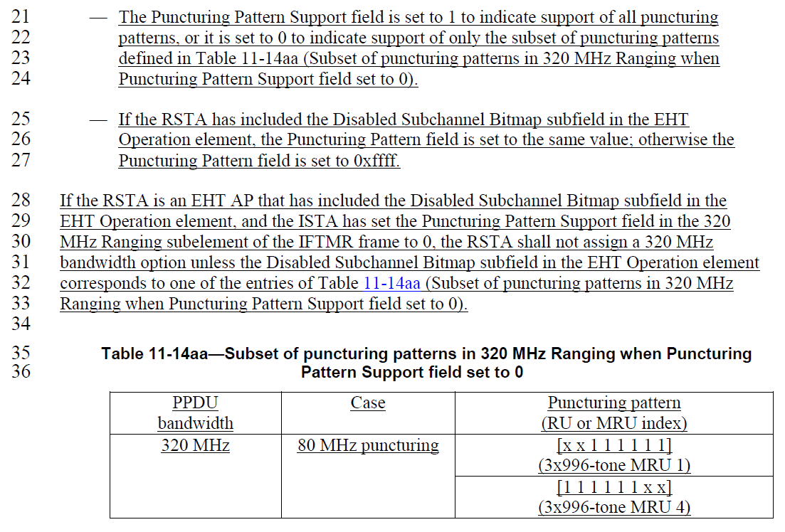

The Puncturing Pattern Support field is defined as follows on P25 in 11bk D1.0,

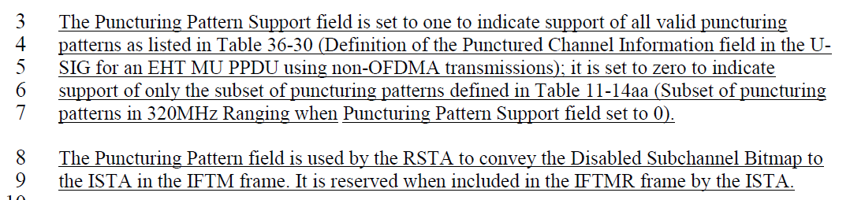

The Disabled Subchannel Bitmap subfield is defined as follows on P245 in 11be D5.0,

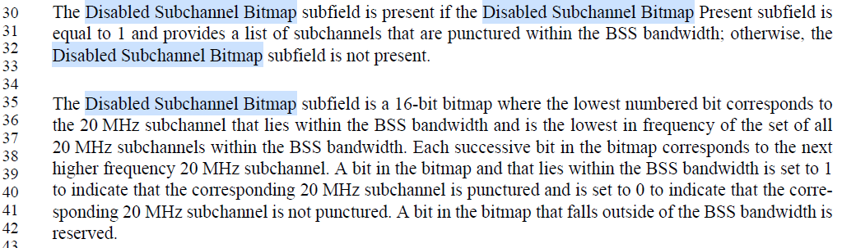

The Disabled Subchannel Bitmap subfield is also explained as follows on P649 in 11be D5.0.

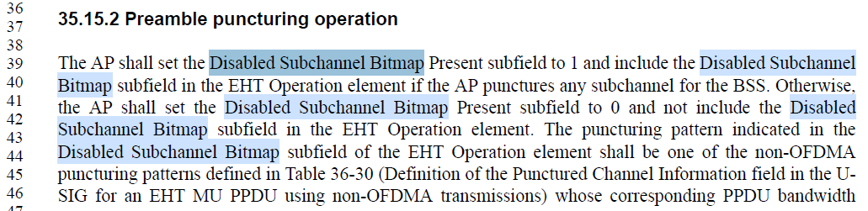

According to Clause 35.15.2, an EHT AP RSTA shall set Disabled Subchannel Bitmap Present subfield in EHT Operation element to 0 to indicate a countinuous 320MHz bandwidth. In other words, an EHT AP RSTA shall not include Disabled Subchannel Bitmap subfield in EHT Operation element if it operates a countinuous 320MHz bandwidth. The RSTA sets Puncturing Pattern field to 0xffff in the 320 MHz Ranging subelement, and the commented table is not applicable in this case.

The commented table and related text describe RSTA behavior when Disabled Subchannel Bitmap subfield is present and ISTA’s Puncturing Pattern Support field is set to 0. But the text misses out the RSTA behavior when Disabled Subchannel Bitmap subfield is present, ISTA’s Puncturing Pattern Support fields is set to 1, and RSTA’s Puncturing Pattern Support fields is set to 0. Propose to add text to complete RSTA behavior description.

Proposed resolution:

To TGbf editor: Please modify the text from P27L28 to L33 as follows.

If the RSTA is an EHT AP that has included the Disabled Subchannel Bitmap subfield in the EHT Operation element, and the ISTA has set the Puncturing Pattern Support field in the 320 MHz Ranging subelement of the IFTMR frame to 0 or the RSTA is to set the Puncturing Pattern Support field in the 320MHz Ranging subelement of the IFTM frame to 0, the RSTA shall not assign a 320 MHz bandwidth option unless the Disabled Subchannel Bitmap subfield in the EHT Operation element corresponds to one of the entries of Table 11-14aa (Subset of puncturing patterns in 320 MHz Ranging when Puncturing Pattern Support field set to 0).

SP:

Do you agree to the resolutions provided for CID 1016 in 802.11-24/0278r0 to be included in 11bk Draft 2.0?

Y/N/A

