IEEE P802.11
Wireless LANs
LB279 Comment Resolution – Clause 11
Date: 2024-02-12
Author(s):
Name | Affiliation | Address | Phone | email
Jonathan Segev | Intel |  |  | jonathan.segev@intel.com

Abstract
This submission proposes to address the following CIDs 1081, 1234, 1278, 1050, 1156, 1279, 1034, 1082, 1137, 1138, 1367, 1368, 1083, 1035, 1084, 1287, 1288 (total of 17) based in Draft P802.11REVme_D4.2, and Draft P802.11bk D1.0.

Revisions:

Interpretation of a Motion to Adopt

A motion to approve this submission means that the editing instructions and any changed or added material are actioned in the TGax Draft. This introduction is not part of the adopted material.

Editing instructions formatted like this are intended to be copied into the TGbk Draft (i.e. they are instructions to the 802.11 editor on how to merge the text with the baseline documents).

TGbk Editor: Editing instructions preceded by “TGbk Editor” are instructions to the TGbk editor to modify existing material in the TGaz draft. As a result of adopting the changes, the TGbk editor will execute the instructions rather than copy them to the TGbk Draft.

The text preceded by “Discussion” is not part of the adopted changes.

CID | P.L | Clause | Comment | Proposed Change | Resolution
1081 | 40.8 | 11.21.6.4.3.4 | "NOTE--if there is only one R2I LMR, the frame is carried in an HE SU PPDU, HE MU PPDU or EHT MU PPDU (including EHT SU transmission) and this does not include VHT/HT/non-HT PPDUs.". The last part of the sentence "and this does not include VHT/HT/non-HT PPDUs" looks redundant. | Delete "and this does not include VHT/HT/non-HT PPDUs" | Revise.  Agree in principle, TGbk editor replace the note text with the following:  Note—if there is only one R2I LMR, the PPDU frame carrying the R2I LMR is using one of the following formats HE SU PPDU, HE MU PPDU or EHT MU PPDU (including EHT SU transmission)
1234 | 39.31 | 11.21.6.4.3.4 | Everything from the second comma onwards in "If the Range Reporting is 32 performed in the context of a Secure FTM Session, see 11.21.6.3 (FTM procedure negotiation), 33 the corresponding LMR and FTM; see 11.21.6.5.1 (Availability Window parameter 34 modification); frames shall be transmitted using Protected Fine Timing Action frames, and see 35 9.6.34 (Protected Fine Timing Frame details). " is incomprehensible | As it says in the comment | Revise.  Agree with the commenter, the quoted sentence seems to go out of its way to reference FTM procedure cases that falls under the definition of protection but fails to identify an actionable element.  TGbk editor make changes identified below in r0 of https://mentor.ieee.org/802.11/documents?is_dcn=272&is_year=2024.
1278 | 40.9 | 11.21.6.4.3.4 | "and this does not include VHT/HT/non-HT PPDUs" is odd | Delete the cited text | Revise.  Agree in principle, TGbk editor replace the note text with the following:  Note—if there is only one R2I LMR, the PPDU frame carrying the R2I LMR is limited to HE SU PPDU, HE MU PPDU or EHT MU PPDU (including EHT SU transmission).
1050 | 44.3 | 11.21.6.4.4.2 | "Otherwise, the R2I NDP shall be an HE Ranging NDP and the LMR(s) shall be transmitted in an HE SU PPDU." - Is this changing baesline behavior? | If this is changing baseline behavior it should be removed. | Reject.  This caluse does not change existing beviour.  This is a definition of the Non-TB sequence which is unique to Ranging. It defines the behavior of the sequence for the 320MHz case which is defined solely by this amendment.

Resolution for CIDs 1234:

TGbk editor, make changes identified below to P802.11bk-D1.0 to P.39 clause 11.21.6.4.3.4 Reporting phase of TB ranging measurement:

11.21.6.4.3.4 Reporting phase of TB ranging measurement

If the Range Reporting is performed in the context of a secure FTM session, ,
the corresponding LMR and FTM frames shall be transmitted using Protected Fine Timing Action frames, and see
9.6.34 (Protected Fine Timing Frame details).
Note—for definition of secure FTM session see 11.21.6.3.1(General).(#1278)
CID | P.L | Clause | Comment | Proposed Change | Resolution
1156 | 44.2 | 11.21.6.4.4.2 | Modify the text ".....and the LMR(s) in the corresponding measurement exchange sequence shall be transmitted in an EHT SU transmission. Otherwise, the R2I NDP shall be an HE Ranging NDP and the LMR(s) shall be transmitted in an HE SU PPDU." to | "...and the LMR(s) (i.e., R2I LMR and optionally transmitted I2R LMR) in the corresponding measurement exchange sequence shall be transmitted in an EHT SU transmission. Otherwise, the R2I NDP shall be an HE Ranging NDP and the LMR(s) (i.e., R2I LMR and optionally transmitted I2R LMR) shall be transmitted in an HE SU PPDU. | Reject.  Commenter did not identify an issue or limitation of the current spec, and the additional detailing of the types of possible LMR source and destination does not increase the accuracy of the text, while reducing its readability.
1279 | 42.8 | 11.21.6.4.4.2 | "I2R 9 NDP and R2I NDP, are HE Ranging NDPs or EHT Ranging NDPs" is still not clear | Change to "I2R 9 NDPs and R2I NDPs are either HE Ranging NDPs or EHT Ranging NDPs" | Accept.  Discussion: the existing text suggest leaves open the possibility of mixing HR format and EHT format Ranging NDPs in the same sequence instance.
1034 |  | 11.21.6.4.4.3 | It seems nothing has been changed from the baseline. | Delete 11.21.6.4.4.3. | Accept.  Discussion: originally inserted to allow committee members to fully identify the protocol behavior and relevant clauses. Given no change identified going to initial LB, it should be removed.
1082 | 46.6 | 11.21.6.4.4.3 | "11.21.6.4.4.3 Non-TB ranging measurement reporting phase". Not sure why this is included in the amendment. It doesn't appear to have any changes relative to the baseline. | Check if there are changes in this section. If not, no need to include. | Accept.  Discussion: originally inserted to allow committee members to fully identify the protocol behavior and relevant clauses. Given no change identified going to initial LB, it should be removed.
1137 | 48.12 | 11.21.6.4.4.3 | "Therefore, the CFO parameter field in the I2R LMR, if negotiated, and R2I LMR are reserved." Please further clarify the specific operations of "negotiated" and "reserved" here. What does negotiation and reservation specifically represent? What should the initiator and responder do? | as in comment | Reject.  The I2R LMR and the R2I LMR are using the same frame format LMR, as such the CFO parameter field space exists in both, however only in the case of the I2R LMR it carries a valid value if negotiated or reserved if its sent from RSTA to ISTA. This is baseline behavior and was not changed in 11bk.
1138 | 46.13 | 11.21.6.4.4.3 | Is "MinTimeBetweenMeasurements" a proprietary term in Figures 13-37k? maybe a specific explanation or definition can be given here | as in comment | Revise.  The Min Time Between Measurements is well defined in the baseline spec, refer to IEEE 802.11az-2022.  TGbk editor in figure 11-37k change MinTimeBetweenMeasurements to Min Time Between Measurements .
1367 | 48.03 | 11.21.6.4.4.3 | What is an "HE/EHT Ranging NDP"? Is this supposed to mean either an HE Ranging NDP or EHT Randing NDP? Also, TGbe D5.0 doesn't have "EHT ranging NDP", it has "EHT sounding NDP" - has there been a renaming along the way somewhere (and 11bk needs to catch up)? | Correct the terminology in this text. Same thing at P50.41, P51.3, P52.9, P52.18, P53.13, P53.14, P53.15 (x2), P53.17, P52.24, P53.26, P53.28, P57.3, P57.,5, P57.10, P57.18, P57.22, P57.26, P58.7, P58.8, P57.10, P57.11, P57.13, P64.5, P64.22, P64.25, P65.1, P65.5, P71.9, P71.10, P71.24, P72.3, P72.4, P72.10, P72.22, P72.23, P72.25, P75.3. | Revise.  Discussion: this is a duplicate of 1282, the TGbk editor instruction below are identical of those provided in resolution to 1282 (already adopted).  TGbk editor replace all instances of HE/EHT Ranging NDP with HE Ranging NDP or EHT Ranging NDP. (27 instances).
1368 | 50.33 | 11.21.6.4.5.2 | What is a "secure HE/EHT-LTF"? Is this supposed to mean a secure HE LTF or a secure EHT LTF, and is there a difference between those (see another comment)? | Same thing at P51.4, P52, 10, P52.20, P52.34, P56.19, P56.34, P57.19, P57.39. | Revise.  Discussion: this is a duplicate of 1083.  TGaz editor replace all instances of ecure HE/EHT-LTF” with “secure LTF”.
1083 | 52.10 | 11.21.6.4.5.2 | The term "secure HE/EHT-LTF" is used on lines 10, 20 and 34 of page 52. Elsewhere, the term "secure LTF" is used. Which is preferred? Better to consistently use one of the two terms. | Use consistent terminology. Check other possible occurences throighout the spec. | Revise.  Discussion: this is a duplicate of 1368.  TGaz editor replace all instances of ecure HE/EHT-LTF” with “secure LTF”.
1035 |  | 11.21.6.4.7 | It seems nothing has been changed from the baseline. | Delete 11.21.6.4.7. | Accept.  Discussion: this is a duplicate of 1084.
1084 | 69.69 | 11.21.6.4.7 | 11.21.6.4.7 shows no highlighted changes. Why is it included in the amendment? | Remove from amendment is no changes in this section | Accept.  Discussion: this is a duplicate of 1035.
1287 | 69.1 | 11.21.6.4.7 | It's not clear what has changed in this subclause | Clarify | Revise.  TGbk editor remove section 11.21.6.4.7.  Discussion: this is a duplicate of 1035, 1084.
1288 | 71.31 | 11.21.6.4.8.3 | " TXVECTOR parameter CH_BANDWIDTH of the Passive Sounding Ranging Trigger frame" -- a TXVECTOR is associated with a PSDU, not an MPDU | As it says in the comment | Revise.  TGbk editor make changes identified below in r0 of https://mentor.ieee.org/802.11/documents?is_dcn=272&is_year=2024.
1391 | 77.42 | 11.21.6.4.9 | Clause 11.21.6.4.9 has already been in REVme D4.1. | Remove lines P77L42 - P79L22 | Accept

Resolution for CID 1288:

TGbk editor, make the changes identified below to P802.11bk-D1.0 P.71 L26-32 clause 11.21.6.4.8.3:
If the Passive Sounding Ranging Trigger frame is soliciting an HE Ranging NDP, the RSTA shall set the associated (#1288) TXVECTOR parameter CH_BANDWIDTH to be the same value as the UL BW subfield of the Common Info field in the Passive Sounding Ranging Trigger frame. Otherwise, the RSTA shall set the associated (#1288) TXVECTOR parameter CH_BANDWIDTH of the Passive Sounding Ranging Trigger frame to CBW320.

1158 | 67.23-26 | 11.21.6.4.6 | The text "If the FORMAT parameter is set to HE_SU, The TXOP_DURATION parameter is set to either 127 or a value defined in Equation (26-3), replacing DHE_NDPA by DRanging_NDP_Announcement which is the value of the Duration/ID field in the MAC header of the preceding Ranging NDP Announcement frame." only relevant to I2R NDP and not R2I NDP. It seems like we need to add a new equation and consider transmission time of the preceding I2I NDP +SIFS for R2I NDP | As per comment | Revise.  Refer to discussion and resolution in r0 of https://mentor.ieee.org/802.11/documents?is_dcn=272&is_year=2024  TGbk editor make changes identified below in r0 of https://mentor.ieee.org/802.11/documents?is_dcn=272&is_year=2024
1159 | 67.27-30 |  | The text "If the FORMAT parameter is set to EHT_MU, the TXOP_DURATION parameter is set to either 127 or a value defined in Equation (35-2), replacing DEHT_NDPA by DRanging_NDP_Announcement which is the value of the Duration/ID field in the MAC header of the preceding Ranging NDP Announcement frame." only relevant to I2R NDP and not R2I NDP. It seems like we need to add a new equation and consider transmission time of the preceding I2I NDP +SIFS for R2I NDP | As per comment | Refer to discussion and resolution in r0 of https://mentor.ieee.org/802.11/documents?is_dcn=272&is_year=2024  TGbk editor make changes identified below in r0 of https://mentor.ieee.org/802.11/documents?is_dcn=272&is_year=2024

Discussion CID 1158, 1159:
The commenter refers to R2I NDP not being addressed by this paragraph, however the paragraph deals with ISTA transmission not RSTA.
The paragraph starts in P.66 L.12 and deals with TXVECTOR setting for transmission of HE/EHT Ranging NDP by an ISTA, thus transmission of R2I NDP is irrelevant. I2R NDPs using HE/EHT Ranging are transmitted in NTB only and only as part of a sequence where an NDPA is transmitted prior to the I2R NDP.
The correct paragraph to reference for transmission of R2I NDP (by an RSTA) in an HE/EHT Ranging NDP format is on P.65 L.21 and the setting of the TX_DURATION parameter is on P.66 L3-10 for the HE SU and EHT MU cases for the setting of TX_DURATION.

There are two cases of R2I NDP transmission:
As part of a TB sequence – where the transmission is preceded by an NDPA, thus the equation 26-3 holds.
As part of an NTB sequence – where the transmission is preceded by an I2R NDP, thus equation 26-3 does not hold, but an additional NDP duration and SIFS duration should be made. Note that the preceeding I2R NDP does not have MAC header/ID field and thus the reference should be made to the HE-SIG-A TXOP PHY subfield of the preceding I2R NDP or the NDPA preceding the I2R NDP (see table below from 802.11ax-2020):
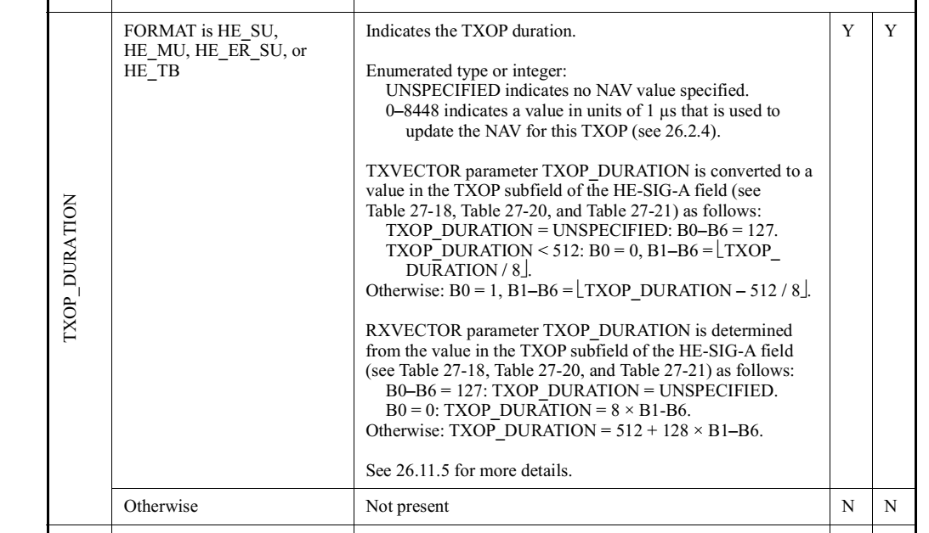
Resolution for CID 1158,1159:

TGbk editor, make the changes identified below to P802.11bk-D1.0 P.66 L.3-10:

- If the FORMAT parameter is set to HE_SU, and the measurement exchange is TB, Tthe TXOP_DURATION parameter is set to either 127 or a value defined in Equation (26-3), replacing D_{HE_NDPA} by D_{Ranging_NDP_Announcement} which is the value of the Duration/ID field in the MAC header of the preceding Ranging NDP Announcement frame.
- If the FORMAT parameter is set to EHT_MU, and the measurement exchange is TB, the TXOP_DURATION parameter is set to either 127 or a value defined in Equation (35-2), replacing D_{EHT_NDPA} by D_{Ranging_NDP_Announcement} which is the value of the Duration/ID field in the MAC header of the preceding Ranging NDP Announcement frame.

- If the FORMAT parameter is set to HE_SU, and the measurement exchange is non-TB, the TXOP_DURATION parameter is set to either 127 or a value defined in Equation (26-3), replacing D_{HE_NDPA} by D_{Ranging_NDP} which is the value of the TXOP field within the HE-SIG-A2 of the preceding I2R NDP.
- If the FORMAT parameter is set to EHT_MU, and the measurement exchange is TB, the TXOP_DURATION parameter is set to either 127 or a value defined in Equation (35-2), replacing D_{EHT_NDPA} by D_{Ranging_NDP} which is the value of the TXOP field within the U-SIG of the preceding I2R NDP.

