IEEE P802.11
Wireless LANs
SA Ballots CR for EHT-SIG and Annex Z
Date: Feb 22, 2024
Author(s):
Name | Affiliation | Address | Phone | email
Ross Jian Yu | Huawei |  |  | ross.yujian@huawei.com
Ming Gan | Huawei

Abstract
This submission proposes resolutions for following 2 CIDs received for initial SA ballots:
CID 22152 and 22350
Revisions:
- Rev 0: Initial version of the document.

CID 22152
CID | Page | Clause | Comment | Proposed Change | Resolution
22152 | 793.8 | 36.3.12.8.3 | Table 36-34 RU allocation subfield includes several small MRU locations that may become “not defined” when PPDU bandwidth is 80MHz or higher, according to Table 36-10 Indices for small size MRUs in an OFDMA 80 MHz EHT PPDU, Table 36-11 and Table 36-12. Should clarify if such RU allocation subfield values are allowed to be used or not. | Add the following to the subclause: "An RU allocation subfield shall not indicate a 52+26 or 106+26 small MRU location that is not defined in an 80 MHz, 160 MHz or 320 MHz PPDU, as specified by Table 36-10, Table 36-11 and Table 36-12." | REVISED  Reflect the changes in detail. Refer to the whole subclause instead of three specific tables, making the reference more complete.  Instructions to the editor:  Please make the changes as shown in 11/24-0260r0 tagged with #CID 22152

TGbe editor, please add the following paragraph to P793, line 22 of P802.11be D5.0 for SA ballot as shown below:
An RU Allocation subfield shall indicate an RU or MRU as defined in 36.3.2 (Subcarrier and resource allocation) (#CID 22152).

CID 22350
CID | Page | Clause | Comment | Proposed Change | Resolution
22350 | 998.40 | Annex Z | [Xiaogang Chen] in example 5 and 6 the last hex octs is half octect. should be 00 to make it full octet as other examples did. | either make it full octet in example 5,6 or keep half octet also in other examples | REVISED  Reflect the changes in detail  Instructions to the editor:  Please make the changes as shown in 11/24-0260r0 tagged with #CID22350.
Discussion:
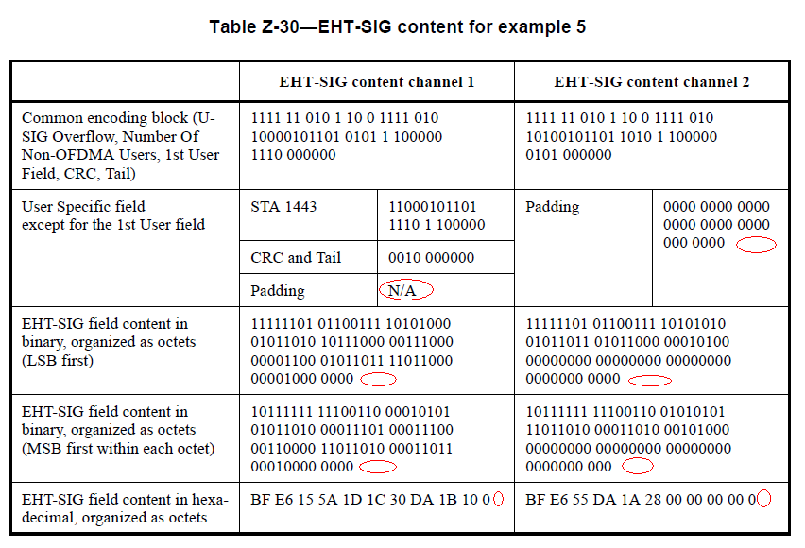
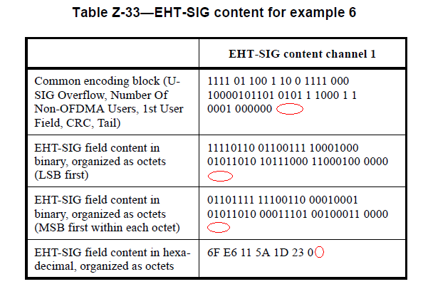
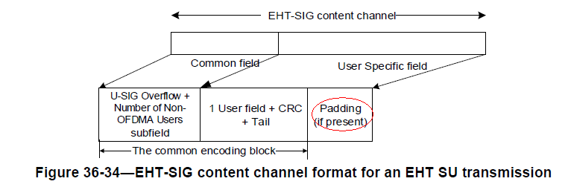
Discussion ends
TGbe editor, please add the following changes to P995, line 20 of P802.11be D5.0 for SA ballot as shown below:
Table Z-30—EHT-SIG content for example 5

 | EHT-SIG content channel 1 |  | EHT-SIG content channel 2
Common encoding block (U- SIG Overflow, Number Of Non-OFDMA Users, 1st User Field, CRC, Tail) | 1111 11 010 1 10 0 1111 010  10000101101 0101 1 100000  1110 000000 |  | 1111 11 010 1 10 0 1111 010  10100101101 1010 1 100000  0101 000000
User Specific field  except for the 1st User field | STA 1443 | 11000101101  1110 1 100000 | Padding | 0000 0000 0000  0000 0000 0000  000 0000 0000 (#CID 22350)
 | CRC and Tail | 0010 000000
 | Padding | 0000 (#CID 22350)
EHT-SIG field content in binary, organized as octets (LSB first) | 11111101 01100111 10101000  01011010 10111000 00111000  00001100 01011011 11011000  00001000 00000000 (#CID 22350) |  | 11111101 01100111 10101010  01011011 01011000 00010100  00000000 00000000 00000000  0000000 00000000 (#CID 22350)
EHT-SIG field content in binary, organized as octets (MSB first within each octet) | 10111111 11100110 00010101  01011010 00011101 00011100  00110000 11011010 00011011  00010000 00000000 (#CID 22350) |  | 10111111 11100110 01010101  11011010 00011010 00101000  00000000 00000000 00000000  0000000 0000000 (#CID 22350)
EHT-SIG field content in hexa- decimal, organized as octets | BF E6 15 5A 1D 1C 30 DA 1B 10 00 (#CID 22350) |  | BF E6 55 DA 1A 28 00 00 00 00 00 (#CID 22350)

TGbe editor, please make the following changes to P996, line 29 of P802.11be D5.0 for SA ballot as shown below:
 | EHT-SIG content channel 1
Common encoding block (U-SIG Overflow, Number Of Non-OFDMA Users, 1st User Field, CRC, Tail), Padding (#CID 22350) | 1111 01 100 1 10 0 1111 00010000101101 0101 1 1000 1 10001 000000 0000 (#CID 22350)
EHT-SIG field content in binary, organized as octets  (LSB first) | 11110110 01100111 10001000 01011010 10111000 11000100 00000000 (#CID 22350)
EHT-SIG field content in binary, organized as octets  (MSB first within each octet) | 01101111 11100110 00010001 01011010 00011101 00100011 00000000 (#CID 22350)
EHT-SIG field content in hexadecimal, organized as octets | 6F E6 11 5A 1D 23 00 (#CID 22350)

