IEEE P802.11
Wireless LANs
LB281 comment resolutions for DMG part 1
Date: 2024.02.xx
Author(s):
Name | Company | Address | Phone | email
Rui Du | Huawei Technologies | F3, Huawei Base, Shenzhen, Guangdong, China, 518129 |  | Ray.du@huawei.com
Narengerile
Zhuqing Tang
Ziyang Guo
Yiyang Zhang
Abstract
This submission contains the proposed comment resolutions for the CIDs 4067, 4066, 4078 and 4065.

R0: initial document
R1: editorial modificaitons and fix the DCN in SP.

CID 4067

CID | Page.  Line | Clause Number | Comment | Proposed Change | Resolution
4067 | 95.20 | 9.4.2.330.1 | In Figure 9-1001ch DMG Sensing Report element contains DMG Sensing Report field, it is confusing because name of element and name of field are same. | Suggest to change either element name or field name. | Rejected.

Rejected Reason:

This comment aims to make the draft easier for reading.
After further check 11bf and REVme, I found a few examples that the sensing element contains a field with same name. Some example are shown here.

- 11bf D3.0
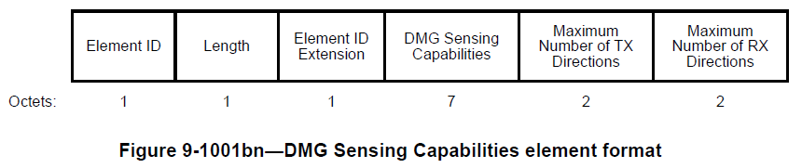

- REVme D4.0

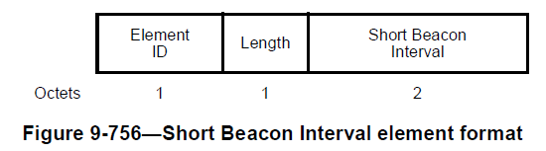

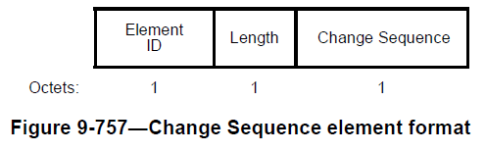

Based on what we have in 11bf and REVme, I think is should be OK to keep what we use now.
The resolution for this commet is rejected.

CID 4066, 4078

CID | Page.  Line | Clause Number | Comment | Proposed Change | Resolution
4066 | 99.18 | 9.4.2.330.3 | In Figure 9-1001cm DMG Sensing Image Report Data element contains "Reflection Fields" field. It may be odd that (sub)field name includes "Fields" as a part of (sub)field name | Suggest to change "Reflection Fields" to e.g. "Reflection Set". Similar wording is used in IEEE802.11-2020, please find "TBTT Information Set" which contains one or more TBTT Information fields. | Accepted.
4078 | 100.07 | 9.4.2.330.3 | This may be a copy and paste error:  "The Receive Elevation Present field indicates the presence of receive azimuth angles in the Reflection subelements."  and should instead be:  "The Receive Elevation Present field indicates the presence of receive elevation angles in the Reflection subelements. | Consider changing "azimuth" to "elevation" in the following sentence:  The Receive Elevation Present field indicates the presence of receive azimuth angles in the Reflection subelements. | Accetped.

Instructions to the editor: please make the following changes to Figure 9-1001cm—DMG Sensing Image Report Data element format in the subclause 9.4.2.330.3 DMG Sensing Image Report Data subelement in D3.0 as shown below:
Figure 9-1001cm – DMG Sensing Image Report Data element format

Instructions to the editor: please make the following changes to paragraphs from P99L52 P100L9 in the subclause 9.4.2.330.3 DMG Sensing Image Report Data subelement in D3.0 as shown below:

The Range Axis Present field indicates the presence of Range Axis Index field in the Reflection Set field.

The Doppler Axis Present field indicates the presence of Doppler Axis Index field in the Reflection Set field.

The Receiver Beam Index Present field indicates the presence of Receiver Beam Index field in the Reflection Set field.

The Transmitter Beam Index Present field indicates the presence of Transmitter Beam Index field in the Reflection Set field.

The Phase Present field indicates the presence of Phsase Value field in the Reflection Set field.

The Receive Azimuth Present field indicates the presence of receive azimuth angles in the Reflection subelements.

The Receive Elevation Present field indicates the presence of receive elevation angles in the Reflection subelements.

Instructions to the editor: please make the following changes to paragraphs from P100L30 P101L8 in the subclause 9.4.2.330.3 DMG Sensing Image Report Data subelement in D3.0 as shown below:

The Number of Reflection Fields field contains the number of Reflection fields present in the Reflection Set field.

The Reflection Set field contains multiple Reflection fields. All Reflection fields within a Reflection Set field have the same format, which can be derived from the Axis Present field. There are 4 format options for 2 axes (Figure 9-1001co (Reflection field format for 2 axes)), 3 axes (Figure 9-1001cp (Reflection field format for 3 axes)), 4 axes (Figure 9-1001cq (Reflection field format for 4 axes)), and 5 axes (Figure 9-1001cr (Reflection field format for 5 axes)). The number of bits allocated for each axis is fixed and given by the axis type.

CID 4065

CID | Page.  Line | Clause Number | Comment | Proposed Change | Resolution
4065 | 124.45 | 9.6.21.8 | In Figure 9-1252a DMG Measurement Session ID field contains DMG Measurement Session ID (sub)field, it is confusing because both field names are same. | Align naming with a case for sub7GHz format. In Figure 9-1198c Measurement Session ID indication field includes Measurement Session ID (sub)field so that we can distinguish both fields easily. | Revised  TGbf Editor make changes specified in 24/0245r1.  (https://mentor.ieee.org/802.11/dcn/24/11-24-0245-01-00bf-lb281-comment-resolutions-for-dmg-part-1.docx)

Instructions to the editor: please make the following changes to the Table 9-589a—DMG Sensing Measurement Request frame Action field format in the subclause 9.6.21.8 DMG Sensing Measurement Request frame format in D3.0 as shown below:

Table 9-589a—DMG Sensing Measurement Request frame Action field format

Order | Information
1 | Category
2 | Unprotected DMG Action
3 | Dialog Token
4 | DMG Measurement Session ID Indication
5 | DMG Sensing Measurement Session element

Instructions to the editor: please make the following changes to the paragraphs from P124L36 to P124L50 in the subclause 9.6.21.8 DMG Sensing Measurement Request frame format in D3.0 as shown below:

The DMG Measurement Session ID Indication field indicates a DMG Measurement Session ID that identifies assigned operational parameters in the DMG Sensing Measurement Session element to be used in the corresponding DMG sensing measurement exchanges as shown in Figure 9-1252a (DMG Measurement Session ID Indication field format).
Figure 9-1252a—DMG Measurement Session ID Indication field format

Instructions to the editor:
please change the DMG Measurement Session ID to DMG Measurement Session ID Indication to the tables and paragraphs in D3.0 as shown below:

- Table 9-589b—DMG Sensing Measurement Response frame Action field format
- P125L44 to P125L47

- Table 9-589d—DMG Sensing Measurement Termination frame Action field format
- P127L37 to P127L38

- Table 9-589f—DMG SBP Response frame Action field format
- P129L25-P129L28

- Table 9-589h—DMG SBP Termination frame Action field format
- P131L63 to P131L65

- Figure 9-1001ch—DMG Sensing Report element format
- P95L32 to P95L35

SP
Do you support resolutions to the following CIDs and incorporate the text changes into the latest TGbf draft: 4067, 4066, 4078 and 4065 in 11-24/0245r1?

Y/N/A

