IEEE P802.11
Wireless LANs
CR for SBP part2 in LB 281
Date: 2024-01-26
Author(s):
Name | Affiliation | Address | Phone | email
Xiandong Dong | Xiaomi |  |  | dongxiandong@xiaomi.com
Abstract
This submission proposes resolutions for following 5 CIDs received for LB281:4086 4307 4007 4009 4053
The proposed changes are based on 802.11bf D3.0

Revisions:
- Rev 0: Initial version of the document.

CID | Commenter | Clause | Page | Comment | Proposed Change | Resolution
4086 | Xiandong Dong | 11.55.2.4 | 170.21 | The SBP responder (AP) can only send either the SBP termination frame or the sensing Measurement termination frame in the AVW to the U-STA which is the SBP initiator and also as a sensing responder, whichever comes first, please add a note for the statement. | as in comment | Revise  See proposed change below in <DCN11-24/0217r1>.

Discussion
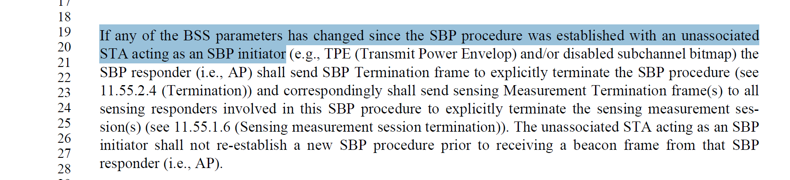

TGbf Editor: Please revise the sentence starting at P170L29 of Clause 11.55.2.4 of D3.0 as follows.

NOTE: In case the SBP initiator is also a sensing responder for this SBP setup then the SBP responder can transmit either a SBP Termination frame during the sensing availability window or a Sensing Measurement Termination frame outside of the sensing availability window, whichever occurs first.(#4086)

CID | Commenter | Clause | Page | Comment | Proposed Change | Resolution
4307 | Fumihide Goto | 11.55.2.2 | 164.41 | It is understandable of the meaning of "the value indicated in the SBP Procedure Expiry Exponent field should be greater  than the value indicated in the Measurement Session Expiry Exponent field" But there are no error procedures. | It is better to define error procedure such as "If the Measurement Session Expiry Exponent is greater than SBP Procedure Expiry Exponent, The Status Code field within the  SBP Response frame shall be set to REQUEST_DECLINED" | Reject  The value is naturally set by the SBP initiator or the SBP responder, not belongs to the setting condition of the error status.

Discussion
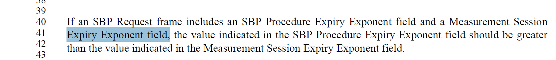

CID | Commenter | Clause | Page | Comment | Proposed Change | Resolution
4007 | Chaoming Luo | 9.4.2.322 | 81.14 | Format issue, the words "Role Bitmap field)." should be put before the figure. | As in comment | revise  See proposed change below in <DCN11-24/0217r1>

Discussion

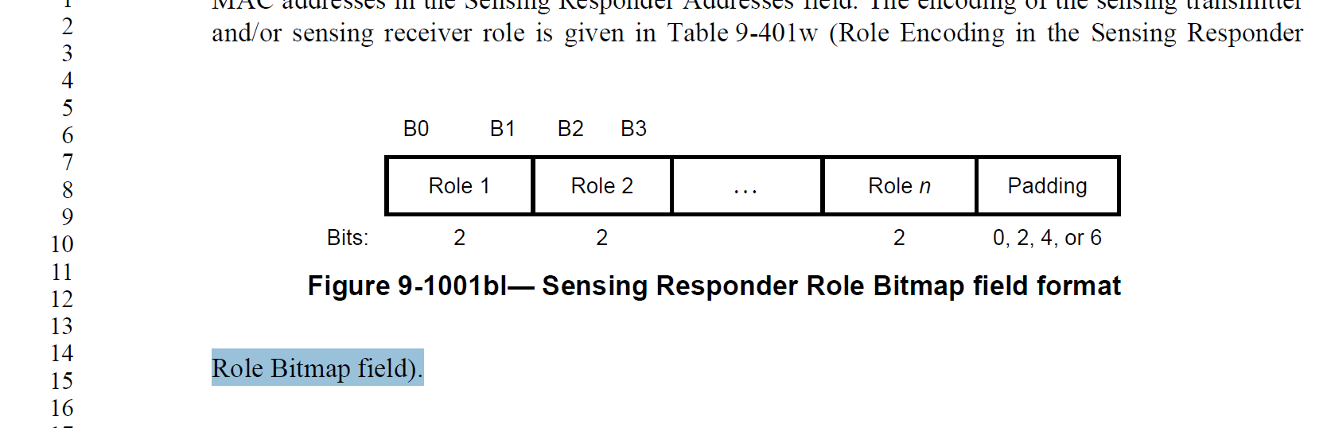

TGbf Editor: Please revise the sentence starting at P81L3 of Clause 9.4.2.322 of D3.0 as follows

The encoding of the sensing transmitter and/or sensing receiver role is given in Table 9-401w (Role Encoding in the Sensing Responder Role Bitmap field). (#4007)
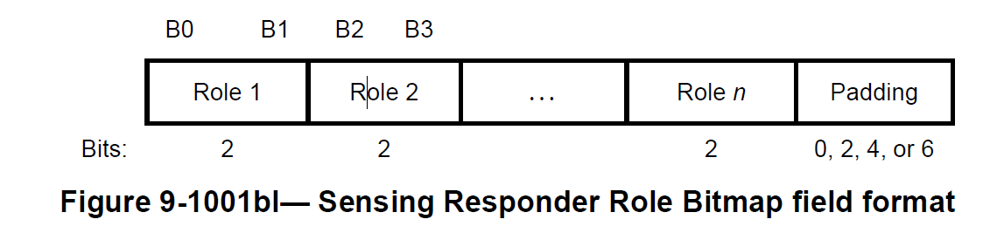

CID | Commenter | Clause | Page | Comment | Proposed Change | Resolution
4009 | Chaoming Luo | 9.4.2.322 | 81.61 | A better wording is needed.  The sentence's intention is to say the value of one field is the same with another field, but the text does not clearly reveal it. | Change to "The value of AID/USID field corresponding to the SBP initiator in the Sensing  Responder IDs field is the same as the AID/USID field within the SBP Response frame."  And it may be even better to change the "AID/USID" field in the SBP Response frame to "SBP Initiator AID/USID" field. | Revise  See proposed change below in <DCN11-24/0217r1>

Discussion
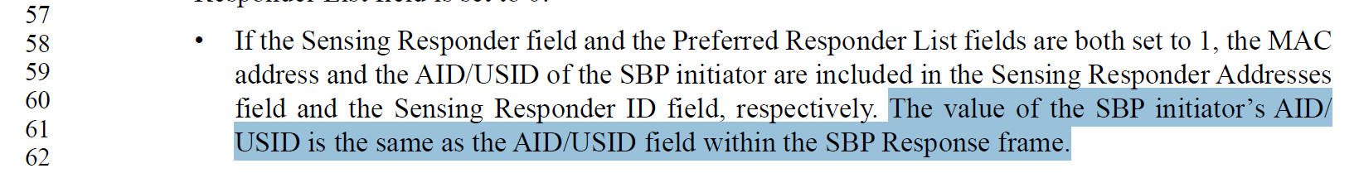
TGbf Editor: Please revise the sentence starting at P81L61 of Clause 9.4.2.322 of D3.0 as follows

If the Sensing Responder field and the Preferred Responder List fields are both set to 1, the MAC
address and the AID/USID of the SBP initiator are included in the Sensing Responder Addresses
field and the Sensing Responder ID field, respectively.
The value of the AID/USID field corresponding to the SBP initiator in the Sensing Responder IDs field is the same as the SBP initiator AID/USID field within the SBP Response frame.(#4009)

TGbf Editor: Please revise the sentence starting at P117L20 of Clause 9.6.7.59 of D3.0 as follows

Category | Public Action/  Protected Dual  of Public Action | Dialog  Token | Status  Code | Measurement  Session ID  Indication | SBP initiator AID/USID
Octets: 1 1 1 2 1 2
Figure 9-1198k—(Protected) SBP Response frame Action field format

TGbf Editor: Please revise the sentence starting at P117L60 of Clause 9.6.7.59 of D3.0 as follows

The SBP initiator AID/USID field is defined in 9.4.1.8 (AID field). If the Status Code field is equal to SUCCESS and if the requesting non-AP STA is associated with the AP, the SBP initiator AID/USID field is set to the requesting non-AP STA’s AID. If the Status Code field is equal to SUCCESS and if the requesting non-AP STA is not associated with the AP, the SBP initiator AID/USID field is set to the requesting non-AP STA’s USID. If the Status Code field is not equal to SUCCESS, the SBP initiator AID/USID field is reserved.

TGbf Editor: Please revise the sentence starting at P165L6 of Clause 11.55.2.2 of D3.0 as follows

If the Status Code field within the SBP Response frame is equal to SUCCESS, the SBP Response frame shall include anSBP initiator AID/USID field that specifies the AID/USID assigned to the SBP initiator.

CID | Commenter | Clause | Page | Comment | Proposed Change | Resolution
4053 | Chaoming Luo | 11.55.2.4 | 169.52 | A better wording is needed to make it easier to read. | Change the two paragraphs to:  An SBP procedure may be terminated by the  SBP initiator by transmitting an SBP Termination frame at any time.  An SBP procedure may be terminated by the  SBP Responder by transmitting an SBP Termination frame at any time, if the SBP initiator is associated with the SBP responder. If the SBP responder intends to terminate an SBP procedure with an SBP initiator that is not associated with, the SBP responder should transmit an SBP Termination frame during the sensing availability window in which the SBP initiator is present. | Accept

Discussion
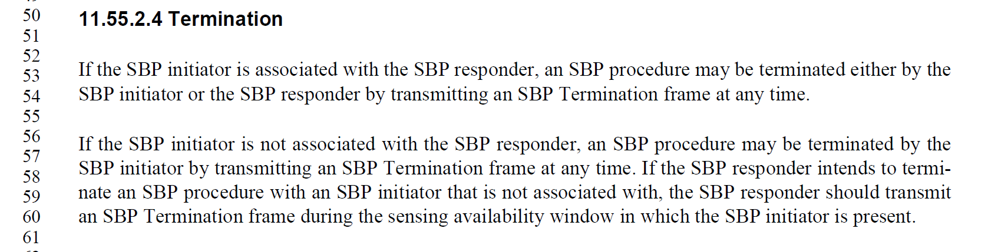

CID | Commenter | Clause | Page | Comment | Proposed Change | Resolution
 | Chaoming Luo | 11.55.2.2 | 164.29 | The sentence "The SBP Request frame shall include a valid SBP Parameters element and a Sensing Measurement Parameters element." does not give much information, since we have detailed text saying how to set the fields. | Remove the commented sentence. | Accept

Discussion
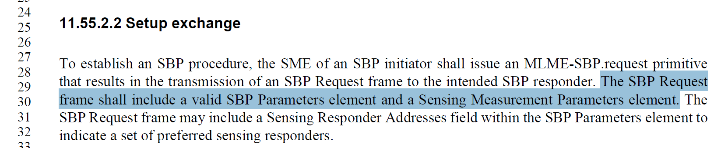

SP: Do you support the resolution to the following 5 CIDs and to incorporate the changes proposed in IEEE 802.11-24/0217r1 to the latest 11bf draft for the following CIDs: 4086 4307 4007 4009 4053 4047?

