IEEE P802.11
Wireless LANs
LB281 resolutions on primitive-related comments
Date: 2024-01-22
Author(s):
Name | Affiliation | Address | Phone | email
Narengerile | Huawei | Shenzhen, China |  | narengerile@huawei.com
Rui Du
Mengshi Hu
Zhuqing Tang
Yiyan Zhang

Abstract
This document proposes the LB281 comment resolution for CIDs 4068, 4080, 4291, 4177, 4037.

R0: initial version on Jan 22, 2024.
R1: revised version on Feb 5, 2024. Modified resolution on CID 4037 to include the SR2SR case.

4068, 4080, 4291
CID | Clause | Page | Comment | Proposed change | Proposed resolution
4068 | 6.5.25.1.4.2 | 26.46 | MeasurementExchangeID Valid range is referenced to 11.55.1.5.1 (General). However, the referenced subclause does not define the valid range. | Please change the reference to 9.4.1.73.1 (General) as it contains in Table 9-127g (Segmentation Control field) a definition. | Accepted.
4080 | 6.5.25.1.4.2 | 26.47 | To be more clear, it is better to rephrase the descrption sentence as "Identifies the sensing measurement exchange of a sensing measurement session for the Sensing Measurement Report frame that was sent." | as in comment | Accepted.
4291 | 11.55.1.5.1 | 145.62 | The note references primitives SENSREPORT.indication twice, without using the full name MLME-SENSREPORT.indication. In the paragraph above, the full name MLME-SENSREPORT.indication is used. | Update note to use MLME-SENSREPORT.indication to match with paragraph above. | Accepted.

4177
CID | Clause | Page | Comment | Proposed change | Proposed resolution
4177 | 11.55.1.4.2 | 144.55 | it should be SME to issue the request primitive. | fix the bug | Revised.  Please refer to the modifications with #4177 in DCN 24/0202r0: https://mentor.ieee.org/802.11/dcn/24/11-24-0202-00-00bf-lb281-resolutions-on-primitive-related-comments.docx

Modifications:
To TGbf editor: Please modify the text at P144L55 as follows.
To solicit a sensing measurement session initiation, the SME of an unassociated non-AP STA issues an MLMESENSMSMTQUERY.request primitive that results in the transmission of a Sensing Measurement Query frame to the AP. (#4177)

4037
CID | Clause | Page | Comment | Proposed change | Proposed resolution
4037 | 11.55.1.5.2.6.1 | 155.55 | Better wording is needed. | Change "and that identifies the sensing measurement session corresponding to the MLME-SENSREPORTRQ.request primitive" to "and that indicates the same Measurement Session ID as in the MLME-SENSREPORTRQ.request primitive" | Revised.  I agree with the commenter that this sentence needs better wording.  The original sentence results in some confusion and the proposed change does not clear it. So, I propose another way of refining the sentence. The same change should apply to both NDPA sounding and SR2SR sounding cases.  Please refer to the modifications with #4037 in DCN 24/0202r1: https://mentor.ieee.org/802.11/dcn/24/11-24-0202-01-00bf-lb281-resolutions-on-primitive-related-comments.docx

Discussions:
The original sentence is in subclause 11.55.1.5.2.6.1 Basic reporting phase. There are two “that”s which specify the use of the Sensing Reporting Trigger frame. The commenter was referring to the second “that”. However, the Sensing Reporting Trigger frame does not contain MSID that can identify a sensing measurement session. Actually, the sensing receiver will include the same MSID in the SensingMeasurementReportContainer parameter as the one indicated in the preceding Sensing NDP Announcement frame. Therefore, the proposed change is given as below.
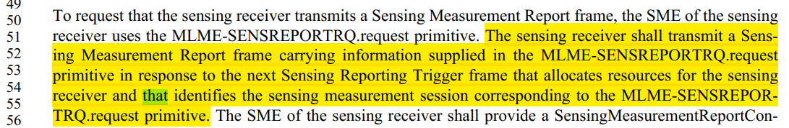
Modifications:
To TGbf editor: Please modify the text at P155L51 as follows.
The sensing receiver shall transmit a Sensing Measurement Report frame carrying information supplied in the MLME-SENSREPORTRQ.request primitive corresponding to the Measurement Session ID indicated in the Sensing NDP Announcement frame or SR2SR Sounding Trigger frame previously received in the same sensing measurement exchange in response to the next Sensing Reporting Trigger frame that allocates resources for the sensing receiver.(#4037)

SP:
Do you agree to the resolution provided for CIDs 4068, 4080, 4291, 4177, 4037 in 24/0202r1 to be included in the latest 11bf Draft?
Y/N/A

