IEEE P802.11
Wireless LANs
SB1 Miscellaneous CIDs
Date: 2024-1-17
Author(s):
Name | Affiliation | Address | Phone | email
Youhan Kim | Qualcomm Technologies, Inc. |  |  | youhank@qti.qualcomm.com

Abstract
This submission proposes resolutions for the following CIDs from SB1 on REVme D4.0:

6209, 6467, 6607, 6006

NOTE – Set the Track Changes Viewing Option in the MS Word to “All Markup” to clearly see the proposed text edits.

Revision History:

R0: Initial version.
R1: Updated the maximum number of segments to 3 (from 8). Also, some editorial updates.
R2: Added a figure for discussion for CID 6006.
R3: Changed “Sounding Feedback” field to “Sounding Feedback Segment” subfield in Figure 9-196b. Also, added the following sentence to 26.7.3: “In this case, the corresponding HE Compressed Beamforming/CQI frame does not include the HE Sounding Feedback Segment field.”
R4: Incorporated feedback from Mark Rison.

CID 6209

CID  Clause  Page.Line | Comment | Proposed Change
6409  25.6.9.2  (No page/line provided) | "the average energy of the OFDM symbols constellations" is grammatically broken. It was suggested during a TGme session at the September F2F that "constellations" might need to remain for some reason | Change each of the 2 instances of the cited text to "the average energy of the OFDM symbols"

Proposed Resolution: CID 6209
REVISED

Instruction to TGme Editor:
Implement the proposed text updates for CID 6209 in https://mentor.ieee.org/802.11/dcn/24/11-24-0085-03-000m-sb1-miscellaneous-cids.docx

Note to Commenter:
The proposed text update updates the grammar. Furthermore, the energy of outer subcarriers are now compared to the average energy of the inner subcarriers for the 540 MHz channel (D4.0 was comparing to the average enery gof the outer subcarriers, which seems to be a typo).

Proposed Text Update: CID 6209
Instruction to TGme Editor: Update REVme D4.2 P3960L6 as shown below.

25.6.9.2 TX flatness

25.6.9.2.1 TX flatness for 540 MHz channel

Let E_{i} denote the constellation energy averaged over OFDM symbols for the subcarrier with index i, and E_{avg} denote E_{i} averaged over i equal to –70 to –2 and +2 to +70. When using the OFDM mode and only while transmitting OFDM symbols, E_{i} with i equal to –70 to –2 and +2 to +70 shall not deviate by more than ± 2 dB from E_{avg}. And E_{i} with i equal to –71 to –89 and +70 to +89 shall not deviate by more than +2/–4 dB from E_{avg}.

25.6.9.2.2 TX flatness for 1080 MHz channel

Let E_{i} denote the constellation energy averaged over OFDM symbols for the subcarrier with index i, and E_{avg} denote E_{i} averaged over i equal to –177 to –2 and +2 to +177. When using the OFDM mode and only while transmitting OFDM symbols, E_{i} with i equal to –146 to –2 and +2 to +145 shall not deviate by more than ± 2 dB from E_{avg}. And E_{i} with i equal to –147 to –177 and +147 to +177 shall not deviate by more than +2/–4 dB from E_{avg}.

CID 6467

CID  Clause  Page.Line | Comment | Proposed Change
6467  (No clause/  page/line provided) | Figure 19-27--PHY receive state machine and Figure 23-53--PHY receive state machine and Figure 21-37--PHY receive state machine and Figure 27-63--PHY receive state machine if midambles are not present have >1 "End of Wait" states | Number each of the End of Wait states, so no state appears twice

Background

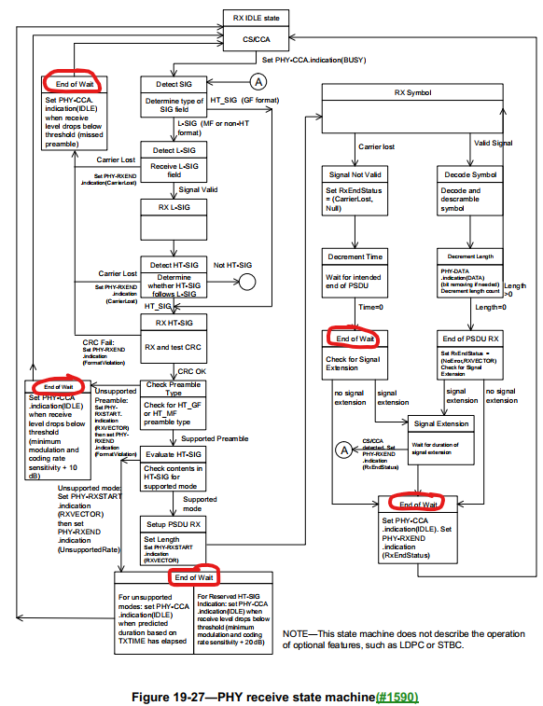

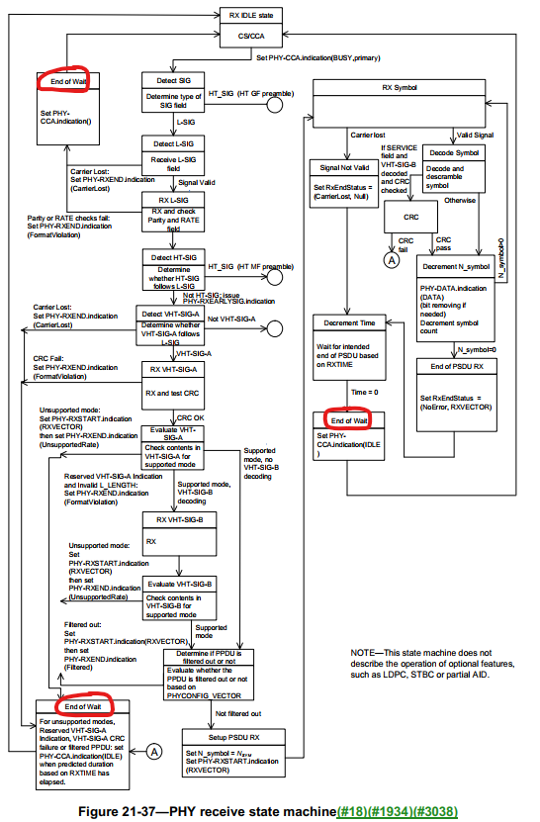

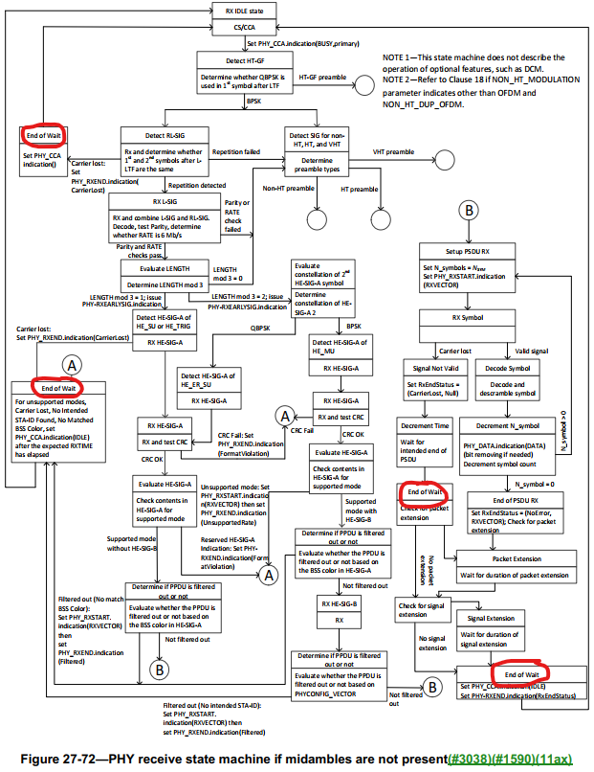

Proposed Resolution: CID 6467
REVISED

Instrcution to TGme Editor:
In Figure 19-27 (REVme D4.2 P3473), change the five “End of Wait” to “End of Wait 1”, “End of Wait 2”, “End of Wait 3”, “End of Wait 4” and “End of Wait 5”.
In Figure 21-37 (REVme D4.2 P3647), change the three “End of Wait” to “End of Wait 1”, “End of Wait 2” and “End of Wait 3”.
In Figure 27-72 (REVme D4.2 P4369), change the four “End of Wait” to “End of Wait 1”, “End of Wait 2”, “End of Wait 3” and “End of Wait 4”.
(It does not matter which of the “End of Wait” gets ‘1’, ‘2’, etc.)

Visio files will be provided to the Editor separately.

Proposed Text Update: CID 6467

CID 6607

CID  Clause  Page.Line | Comment | Proposed Change
6607  E.2.7.6  5544.50 | Recent developments at various regulatory bodies requires the Table E-12 to be updated. | Update Table E-12 (and other areas in the REVme draft) to reflect the latest regulatory situation.

Proposed Resolution: CID 6607
REVISED
CID 6077 has updated the Table E-12 to reflect the latest regulatory situation.

Note to TGme Editor:
No further changes are needed as REVme D4.2 has already incorporated changes for CID 6077.

CID 6006

CID  Clause  Page.Line | Comment | Proposed Change
6006  26.7.4  3912.35 | The text is unclear how MU feedback should be segmented. For example, in each segment, does HE Compressed Beamforming/CQI frame need to include both HE Compressed Beamforming Report and HE MU Exclusive Beamforming Report? Or it may include HE Compressed Beamforming Report and/or HE MU Exclusive Beamforming Report? In other words, some HE Compressed Beamforming/CQI frame may include HE Compressed Beamforming Report only or HE MU Exclusive Beamforming Report only? This issue needs to be clarified since subsequent standards such as 11be are using the style 11ax as reference and may cause more confusions. | Please clarify how the segmentation is performed for SU feedback and MU feedback, e.g., adding the following sentences before the last sentence of the first paragraph of Subclause 26.7.4: If the Feedback Type subfield in the EHT MIMO Control field indicates SU, each feedback segment carried in an HE Compressed Beamforming/CQI frame may contain the HE compressed report information only; if the Feedback Type subfield in the HE MIMO Control field indicates MU, each feedback segment carried in an HE Compressed Beamforming/CQI frame may contain the HE compressed report information, and/or the HE MU exclusive beamforming report information. Plan to submit a contribution.

Discussion

How the HE sounding feedback segmentation is done is not very clearly described as the commenter has indicated. The commenter asks, for example, whether the MU type feedback is segmented in which of the following two ways.

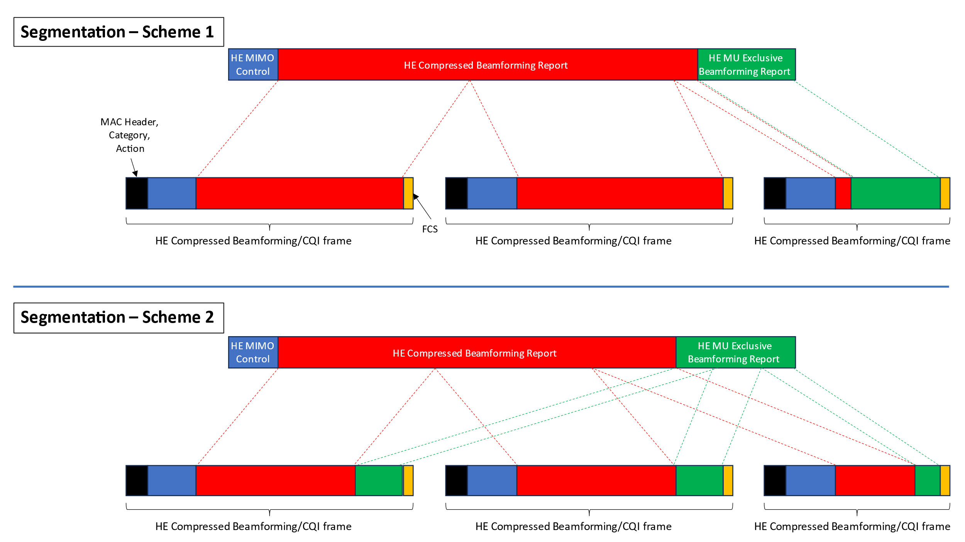

Correct approach is ‘scheme 1’ above.

The proposed text update creates two new ‘intermediate’ fields (HE Compressed Beamforming/CQI Report, HE Sounding Feedback Segement) to make the segmentation process clearer.

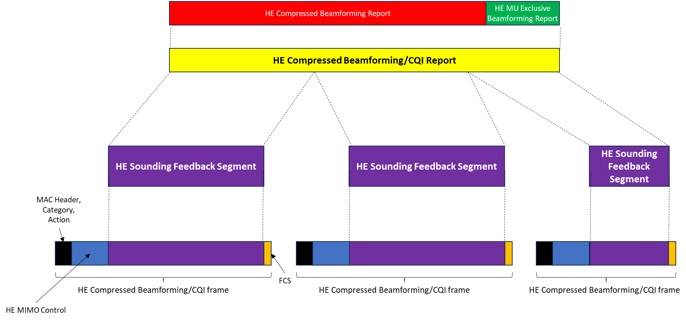

Proposed Resolution: CID 6006
REVISED

Instruction to TGme Editor:
Implement the proposed text updates for CID 6006 in https://mentor.ieee.org/802.11/dcn/24/11-24-0085-04-000m-sb1-miscellaneous-cids.docx

Note to Commenter:
The proposed text update provides mathematical description on how the HE sounding feedback is segmented.

Proposed Text Update: CID 6006
Instruction to TGme Editor: Add the following at REVme D4.2 P866L56.

9.4.1.65a HE Compressed Beamforming/CQI Report field

The HE Compressed Beamforming/CQI Report field carries the HE compressed beamforming/CQI report (see 26.7 (HE sounding operation)) and is defined in Figure 9-196a.

 | HE Compressed Beamforming Report | HE MU Exclusive Beamforming Report | HE CQI Report
Octets: | variable | variable | variable

Figure 9-196a – HE Compressed Beamforming/CQI Report field format

The HE Compressed Beamforming Report field is defined in 9.4.1.63 (HE Compressed Beamforming Report field).

The HE MU Exclusive Beamforming Report field is defined in 9.4.1.64 (HE MU Exclusive Beamforming Report field).

The HE CQI Report field is defined in 9.4.1.65 (HE CQI Report field).

NOTE –The presence of the HE Compressed Beamforming Report field, HE MU Exclusive Beamforming Report field and HE CQI Report field are dependent on the values of the Feedback Type subfield of the HE MIMO Control field in the HE Compressed Beamforming/CQI frame.

9.4.1.65b HE Sounding Feedback Segment field

The HE Sounding Feedback Segment field is defined in Figure 9-196b.

 | Sounding Feedback Segment
Octets: | Variable

Figure 9-196b – HE Sounding Feedback Segment field format

The Sounding Feedback Segment field consists of octets number N1 to N2, where the first octet is octet 1, of the HE Compressed Beamforming/CQI Report field, where N1 and N2 are determined by the HE MIMO Control field of the HE Compressed Beamforming/CQI frame containing the HE Sounding Feedback Segment field (see 26.7.4 (Rules for generating segmented feedback)).

Instruction to TGme Editor: Update REVme D4.2 P1791L30 as shown below.
9.6.31.2 HE Compressed Beamforming/CQI frame format
The HE Compressed Beamforming/CQI frame is an Action No Ack frame of category HE. The Action field of an HE Compressed Beamforming/CQI frame contains the information shown in Table 9-630.
Table 9-630 – HE Compressed Beamforming/CQI frame Action field format
Order | Information | Notes
1 | Category
2 | HE Action
3 | HE MIMO Control (see 9.4.1.62)
4 | HE Sounding Feedback Segment (see 9.4.1.65b) | Optional
The Category field is defined in Table 9-81.
The HE Action field is defined in 9.6.31.1.

A Vendor Specific element is not present in the HE Compressed Beamforming/CQI frame.

Instruction to TGme Editor: Update REVme D4.2 P856L59 as shown below.

9.4.1.62 HE MIMO Control field
…

In an HE Compressed Beamforming/CQI frame that does not include the HE Sounding Feedback Segment field (see 26.7 (HE sounding operation) for a description of such a case), the Nc Index, Nr Index, BW, Grouping, Codebook Information, Feedback Type and Sounding Dialog Token Number subfields are reserved, the First Feedback Segment subfield is set to 0 and the Remaining Feedback Segments subfield is set to 7.

Instruction to TGme Editor: Update REVme D4.2 P857L22 as shown below.

9.4.1.63 HE Compressed Beamforming Report field
…

The size of the HE Compressed Beamforming Report field depends on the values in the HE MIMO Control field. The HE Compressed Beamforming Report field contains HE Compressed Beamforming Report information. The HE Compressed Beamforming Report field is included in the HE Compressed Beamforming/CQI Report field (9.4.1.65a) if the Feedback Type subfield in the HE MIMO Control field indicates SU or MU, and is not included otherwise. If the HE MIMO Control field contains a Disallowed Subchannel Bitmap subfield, then the HE Compressed Beamforming Report field does not include information for tones that are included within 242-tone RUs that are indicated as disallowed by the bitmap.

Instruction to TGme Editor: Update REVme D4.2 P865L23 as shown below.

9.4.1.64 HE MU Exclusive Beamforming Report field
…

The size of the HE MU Exclusive Beamforming Report field depends on the values in the HE MIMO Control field. The HE MU Exclusive Beamforming Report field contains HE MU Exclusive Beamforming Report information. The HE MU Exclusive Beamforming Report field is included in the HE Compressed Beamforming/CQI Report field (9.4.1.65a) (in addition to the HE Compressed Beamforming Report field) if the Feedback Type subfield in the HE MIMO Control field indicates MU, and is not included otherwise. If the HE MIMO Control field contains a Disallowed Subchannel Bitmap subfield, then the HE MU Exclusive Beamforming Report field does not include information for tones that are included within 242-tone RUs that are indicated as disallowed by the bitmap.

Instruction to TGme Editor: Update REVme D4.2 P866L51 as shown below.

9.4.1.65 HE CQI Report field
…

The size of the HE CQI Report field depends on the values in the HE MIMO Control field. The HE CQI Report field contains HE CQI Report information. HE CQI Report information is included in the HE Compressed Beamforming/CQI Report field (9.4.1.65a) if the Feedback Type subfield in the HE MIMO Control field indicates CQI feedback, and is not included otherwise. If the HE MIMO Control field contains a Disallowed Subchannel Bitmap subfield, then the HE CQI Report field does not include information for tones that are included within 26-tone RUs that are indicated as disallowed by the bitmap.

Instruction to TGme Editor: Update REVme D4.2 P4030L22 as shown below.

26.5.2.4 A-MPDU contents in an HE TB PPDU
…

A non-AP STA that responds to a BFRP Trigger frame addressed to it shall construct an A-MPDU carried in the HE TB PPDU with one or more HE Compressed Beamforming/CQI frames (see 26.7 (HE sounding operation)); other frames shall not be allowed in the A-MPDU.
NOTE 5—It is not always possible to segment the HE Compressed Beamforming/CQI Report field (see 26.7.4 (Rules for generating segmented feedback)). If the length of the HE TB PPDU is insufficient to contain the HE compressed beamforming/CQI report requested by a BFRP Trigger frame, no feedback is sent.

Instruction to TGme Editor: Update REVme D4.2 P4051L50 as shown below.

26.7 HE sounding operation
26.7.1 General
…

The HE beamformee returns an estimate of the channel state in an HE compressed beamforming/CQI report carried in the HE Compressed Beamforming/CQI Report field. There are three types of HE compressed beamforming/CQI report:

- SU feedback: The HE Compressed Beamforming/CQI Report field consists of an HE Compressed Beamforming Report field.
- MU feedback: The HE Compressed Beamforming/CQI Report field consists of an HE Compressed Beamforming Report field and HE MU Exclusive Beamforming Report field.
- CQI feedback: The HE Compressed Beamforming/CQI Report field consists of an HE CQI Report field.

NOTE—Use of HE TB sounding does not necessarily imply MU feedback. HE TB sounding is also used to obtain SU feedback and CQI feedback.

TheHE Compressed Beamforming/CQI Report field is carried in a single HE Sounding Feedback Segment fieldif the resulting HE Compressed Beamforming/CQI frame is less than or equal to 11 454 octets in length (see 26.7.3 (Rules for HE sounding protocol sequences)). Otherwise, the HE Compressed Beamforming/CQI Report field is segmented, with each segment carried in an HE Sounding Feedback Segment field, and each HE Sounding Feedback Segment field carried in separate HE Compressed Beamforming/CQI frames.

An HE beamformer shall support a maximum MPDU length for an HE Compressed Beamforming/CQI Report frame that is the minimum of 11 454 octets and the maximum length of the HE Compressed Beamforming/CQI Report frame that the HE beamformer intends to solicit from its HE beamformees.

26.7.3 Rules for HE sounding protocol sequences
…

Instruction to TGme Editor: Update REVme D4.2 P4060L5 as shown below.
An HE beamformee that receives an HE NDP Announcement frame as part of an HE TB sounding sequence with a STA Info field identifying it soliciting SU or MU feedback shall generate an HE compressed beamforming/CQI report using the feedback type, Ng, codebook size, and Nc indicated in the STA Info field. If the HE beamformee then receives a BFRP Trigger frame with a matching STA Info field, the HE beamformee transmits an HE TB PPDU containing the HE compressed beamforming/CQI report following the rules defined in 26.5.2.3 (Non-AP STA behavior for UL MU operation). If the HE NDP Announcement frame has the TA field set to the transmitted BSSID and the HE beamformee is a non-AP STA associated with an AP corresponding to a nontransmitted BSSID that supports receiving Control frames with TA field set to the transmitted BSSID, then the HE Compressed Beamforming/CQI frame(s) sent in response shall have the RA field set to as defined in 26.5.2.3.5 (RA field for frames carried in an HE TB PPDU).

NOTE 2—A non-AP HE beamformee that transmits an OM Control subfield with the UL MU Disable field set to 1 does not respond to BFRP Trigger frames (see 26.9 (Operating mode indication)).

An HE beamformee that is a non-AP STA that transmits an HE Compressed Beamforming/CQI frame shall set the RU Start Index and RU End Index subfields of the HE MIMO Control field to indicate the range of tones for which compressed beamforming/CQI information is provided. If the HE NDP Announcement frame that solicited the feedback includes a Disallowed Subchannel Bitmap field with a nonzero value, then a beamformee that indicates support for punctured sounding by setting the Punctured Sounding Support subfield in the HE Capabilities elements that it transmits to 1 shall include a Disallowed Subchannel Bitmap subfield in the solicited feedback with the same value as the Disallowed Subchannel Bitmap subfield of the HE NDP Announcement frame that solicited the feedback to indicate subcarriers for which feedback information is not provided from within the range of subcarriers indicated by the RU Start Index and RU End Index subfields.

An HE beamformee that transmits HE compressed beamforming/CQI report shall include neither the HE Compressed Beamforming Report field nor the HE MU Exclusive Beamforming Report field in the HE Compressed Beamforming/CQI Report field if the transmission duration of the PPDU carrying the HE Compressed Beamforming/CQI Report field would exceed the maximum PPDU duration. In this case, the HE Compressed Beamforming/CQI frame does not include the HE Sounding Feedback Segment field.

Instruction to TGme Editor: Update REVme D4.2 P4060L48 as shown below.

26.7.4 Rules for generating segmented feedback

The HE Sounding Feedback Segment field consists of bits in octet number N1 to octet number N2 of the HE Compressed Beamforming/CQI Report field (see 9.4.1.65a (HE Compressed Beamforming/CQI Report field)). Let L_{HCBCR} denote the length of the HE Compressed Beamforming/CQI Report field in octets.

If the HE Compressed Beamforming/CQI Report field would result in an HE Compressed Beamforming/CQI frame that does not exceed 11 454 octets in length, then the HE Compressed Beamforming/CQI Report field shall be included in a single HE Sounding Feedback Segment field. In this case, N1 = 1 and N2 = L_{HCBCR} for the HE Sounding Feedback Segment field.

If the HE Compressed Beamforming/CQI Report field would result in an HE Compressed Beamforming/CQI frame that exceeds 11 454 octets in length, then theHE Compressed Beamforming/CQI Report field shall be split into K HE Sounding Feedback Segment fields. Let L be the length of the HE Sounding Feedback Segment field in octets that results in the length of the HE Compressed Beamforming/CQI frame being 11 454 octets (see NOTE 1). Then, the number of HE Sounding Feedback Segment fields is K = Ceil( L_{HCBCR} / L ). For the k-th HE Sounding Feedback Segment field that is not the last HE Sounding Segment field (k = 1, …, K–1), N1 = (k–1) × L + 1 and N2 = k × L. For the last HE Sounding Segment field, N1 = (K–1) × L + 1 and N2 = L_{HCBCR} (see NOTE 3). Each HE Sounding Feedback Segment field shall be included in a separate HE Compressed Beamfsorming/CQI frame. Each HE Sounding Feedback Segment field is identified by the value of the Remaining Feedback Segments subfield and the First Feedback Segment subfield in the HE MIMO Control field in the HE Compressed Beamforming/CQI frame containing the HE Sounding Feedback Segment field as defined in 9.4.1.62; the other nonreserved subfields of the HE MIMO Control field shall be the same for all HE Compressed Beamforming/CQI frames carrying different HE Sounding Feedback Segment fields of the same HE Compressed Beamforming/CQI Report field. All HE Compressed Beamforming/CQI frames carrying different portions of the same HE Compressed Beamforming/CQI Report field shall be sent in a single A-MPDU contained in a PPDU and shall be included in the A-MPDU in the descending order of the Remaining Feedback Segments subfield values.

NOTE 1—An HE Sounding Feedback Segment field together with the other fields in the Frame Body field of the HE Compressed Beamforming/CQI frame (see Figure 9-118 (Management frame format) and Table 9-630 (HE Compressed Beamforming/CQI frame Action field format), constitutes a single unfragmented MMPDU.

NOTE 2 – The maximum length of the HE Compressed Beamforming/CQI Report field is 30 008 octets (160 MHz MU type feedback with 8 columns, 8 rows, Ng = 4 and (ϕ, ψ) = {9, 7} bits – see Table 9-122 (HE MIMO Control field encoding)). Therefore, the maximum number of the HE Compressed Beamforming/CQI frames needed to carry an HE Compressed Beamforming/CQI Report field is 3.

NOTE 3 – This results in all HE Sounding Feedback Segment fields that are not the last HE Sounding Segment field to have equal length. All HE Compressed Beamforming/CQI frames that do not contain the last HE Sounding Feedback Segment field have equal length of 11 454 octets. The last HE Sounding Feedback Segment field might have length smaller than the other HE Sounding Feedback Segment fields. The HE Compressed Beamforming/CQI frame containing the last HE Sounding Feedback Segment field has a length less than or equal to 11 454 octets.

An HE beamformer that sends a BFRP Trigger frame, in its first attempt to retrieve an HE compressed beamforming/CQI report from an HE beamformee, shall solicit all possible HE Sounding Feedback Segment fields (feedback segments) by setting all of the bits in the Feedback Segment Retransmission Bitmap subfield to 1 in the User Info field identifying the HE beamformee.

An HE beamformer that fails to receive some or all of the feedback segments of the HE compressed beamforming/CQI report from the HE beamformee may solicit the selective retransmission of missing feedback segments by sending a BFRP Trigger frame that indicates in the Feedback Segment Retransmission Bitmap subfield of the User Info field identifying the HE beamformee the list of feedback segments solicited for retransmission (see 9.3.1.22.3 (BFRP Trigger frame format)).

NOTE 2—In an HE non-TB sounding sequence, if the HE beamformer does not receive all feedback segments from the HE beamformee, the HE beamformer cannot use a BFRP Trigger frame to request retransmission of the feedback segments. In this case the HE beamformee can only repeat the entire non-TB sounding sequence.

An HE beamformer that fails to receive the first feedback segment (identified by the First Feedback Segment field set to 1), may solicit the selective retransmission of the missing feedback segments assuming the HE Compressed Beamforming/CQI Report field is split into 8 feedback segments. The HE beamformer may also solicit the retransmission of all feedback segments by setting all of the bits in the Feedback Segment Retransmission Bitmap subfield to 1 in the User Info field identifying the HE beamformee.

An HE beamformee that transmits an HE compressed beamforming/CQI report including the HE Compressed Beamforming Report information and any HE MU Exclusive Beamforming Report information in response to a BFRP Trigger frame shall either transmit only the feedback segments indicated in the Feedback Segment Retransmission Bitmap field in the User Info field of the BFRP Trigger frame identifying the HE beamformee or transmit all the feedback segments available at the HE beamformee, excluding the feedback segments that do not exist at the HE beamformee.

NOTE 3—If an HE beamformer solicits the missing feedback segments from a beamformee and does not receive a response from the beamformee, the HE beamformer might either initiate an HE TB sounding sequence or transmit an additional BFRP Trigger frame to the HE beamformee.

[End of File]

